

Erohal

High-Level and Low-Level Design

**Project Advisor:**

Mr. Muhammad Ishaq Raza

**Group Members:**

Muhammad Arsil Khan 16L-4167

Ali Iqbal 16L-4134

Usama Azeem 16L-4351

Abdul Akhir Ihsan 16L-4265

National University of Computer and Emerging Sciences

Department of Computer Science

Lahore, Pakistan

Table of Contents

Table of Contents i

List of Figures iii

1. Introduction 1

1.1 Purpose of this Document 1

1.2 Scope 1

1.3 Intended Audience 1

1.4 Version 1

1.5 Related Documents 1

1.6 Prerequisite Documents 1

1.7 Background of this Document 2

1.8 Definitions, Acronyms, and Abbreviations 2

1.9 Summary 2

2. System Overview 3

2.1 Adding Products 3

2.1.1 Manual 3

2.1.2 Automated Web Scrapping 3

2.2 Extracting Features 3

2.3 User Profiling 3

2.4 Learning Model 3

2.5 Display Products 3

2.6 Feed back 4

3. Design Considerations 5

3.1 Assumptions and Dependencies 5

3.2 General Constraints 5

3.1.1 Hardware or software environment 5

3.1.2 End-user environment 5

3.1.3 Availability or volatility of resources 5

3.1.4 Interoperability requirements 5

3.1.5 Interface/protocol requirements 5

3.1.6 Data repository and distribution requirements 5

3.1.7 Security requirements (or other such regulations) 6

3.1.8 Memory and other capacity limitations 6

3.1.9 Verification and validation requirements (testing) 6

3.1.10 Language Constraints 6

4. Goals and Guidelines 7

4.1 Accuracy 7

4.2 Performance 7

5. Development Methods 8

6. Architectural Strategies 9

6.1 Spring Boot, Python, Vue.js 9

6.2 Future plans for enhancing software 9

6.3 User interface paradigms 9

6.4 Error detection and recovery 9

6.5 Reuse of existing software components to implement various parts of system 9

6.6 Memory management policies 9

7. System Architecture 10

7.1 High-Level Architecture 10

7.2 Low-Level Architecture 11

7.3 Component Diagram 12

8. Class Diagram 15

9. Sequence Diagrams 20

10. Policies and Tactics 54

10.1 Libraries and Database 54

10.2 Coding guidelines and conventions 54

10.3 Testing the software 54

10.4 Maintaining the software 54

10.5 Protocol 54

10.6 Accessing the application 54

11. References 55

List of Figures

Figure 1: System Flow 3

Figure 2: High Level System Architecture 9

Figure 3: Low Level System Architecture 10

Figure 4: Asset Personnel Service Component 11

Figure 5: Inspection Service Component 12

Figure 6: Works Order Service Component 13

Figure 7: Asset Management Service 14

Figure 8: Work Order Service 15

Figure 9: Asset Personnel Service 16

Figure 10: Inspection Service 17

Figure 11: Device Template Service 18

Figure 12: Work Order Time Assignment 19

Figure 13: Work Order Parts and Cost added 20

Figure 14: Work Order Assignment 21

Figure 15: View Issue List 22

Figure 16: View Issue Detail 23

Figure 17: View Inspection List 24

Figure 18: View Inspection Detail 25

Figure 19: View All Service Requests 26

Figure 20: Asset List 27

Figure 21: View All Work Orders 28

Figure 22: Update Item to Existing Template 29

Figure 23: Remove Item to Existing Template 30

Figure 24: Update Inspection Template 31

Figure 25: Login 32

Figure 26: Examine Service Requests 33

Figure 27: Examine Work Order 34

Figure 28: Edit Issue 35

Figure 29: Create New Service Request 36

Figure 30: Create New Work Order 37

Figure 31: Create Issue 38

Figure 32: Create Inspection Template 39

Figure 33: Asset Information 40

Figure 34: Add Item to Existing Template 41

Figure 35: Add a Member in User Group 42

Figure 36: Add a New Role 42

Figure 37: Add an Assignment 43

Figure 38: Add an Asset Image 43

Figure 39: Change Password 44

Figure 40: Create a User group 44

Figure 41: Create Asset 45

Figure 42: Delete a Role 45

Figure 43: Delete an Assignment 46

Figure 44: Edit a Profile 46

Figure 45: Remove a Member from User Group 47

Figure 46: Select Asset Category 47

Figure 47: Update a Role 48

Figure 48: View All User Groups 48

Figure 49: View Asset Assignment History 49

Figure 50: View Consumptions 49

Figure 51: View Filtered Consumptions of an Asset 50

Figure 52: View Filtered Usages of an Asset 51

Figure 53: View Usages 51

Figure 54: View User Profile 52

# Introduction

Panda Mall is a web-based recommendation system designed to recommend fashion and clothing products from hundreds of online shopping stores based on the preferences of the user. This would reduce the problem of choice overload [1], bring many stores under one roof and allow startups to find potential customers. Data of fashion products will either be scrapped from various websites or from a registration form on the website and through RS model those products will be recommended to the registered customers.

## Purpose of this Document

The goal of this document is to provide a full overview of our project's high- and low-level design. For a better understanding of the project, it includes development methodologies and architectural strategies to be followed, as well as class and sequence diagrams. This document tries to demonstrate the interaction of system modules in order to better depict the system's flow and operating sequence.

## Scope

The scope of Panda Mall includes:

* Manual registration of products/brands and automated web scraping
* Training data in ML model using standard RS algorithms.
* Developing a web-based GUI for the users, admin and brands.

## Intended Audience

* Clothing brand owners
* Online shoppers

The aim is to facilitate both shoppers and brands to get the experience of a shopping mall online.

## Version

This is the first version of the high- and low-level design document for Panda Mall.

## Related Documents

This document is linked to the following previously submitted documents:

* Project Proposal
* Software Requirements Specifications
* Software Functional Specifications

## Prerequisite Documents

This document expands on the ideas presented in the previous documents.:

* Project Proposal
* Software Requirements Specifications
* Software Functional Specifications

## Background of this Document

This document divides the architectural design supplied in the FS documents into high- and low-level designs, and adds more to them, such as a class and sequence diagram, to better illustrate how the project works.

## Definitions, Acronyms, and Abbreviations

FS: Functional specification

RS: Recommender System

ML: Machine Learning

GUI: Graphical User Interface

JS: JavaScript

OS: Operating System

## Summary

This document primarily explains the system's high- and low-level structure. The introduction provides a general idea of the project by explaining the context, goals, and purpose of the document. Then there's a system overview, which depicts the system's flow from a broader scope while highlighting the start and end of sequence. The high- and low-level diagrams, as well as the component diagram of the system, are included in the system architecture, which also specifies the architectural styles that will be implemented and how the modules will interact with one another. Furthermore, class and sequence diagrams will aid in the comprehension of the system's flow or sequence of interactions. In addition, the document covers the document's goals and guidelines, as well as the development methodologies that will be employed, component dependencies, and general policies and tactics.

# System Overview

Figure 1: System Flow

Basic system flow diagram.

Adding Products

Extracting features

User profiling

Applying learning model

Display products

Feed back



## Adding Products

There are two ways for adding products on Panda Mall:

### Manual

Brand accounts can fill out forms of the products they wish to add to Panda Mall and an admin must approve before publishing.

### Automated Web Scrapping

Panda Mall System automatically scrapes product pages of popular e-commerce brands and add them to website.

## Extracting Features

Once the products are added to the system. Their features like price, color is extracted for the model to learn from.

## User Profiling

In the next step, customers signup and they are asked about their basic preferences as a starting point for the model to profile the features a user is most likely to appreciate or discard.

## Learning Model

After the products and user data is collected, cleaned and analyzed the machine learning model uses it to create an RS system capable of rearranging products based on the user profiling.

## Display Products

In the final product, when the customer logs in using valid credentials, the output of the RS system is utilized to organize the products for the particular customer preferences. They can buy the product by redirecting to the product page, add to favorites or apply filters to narrow down searches.

## Feed back

Customers are reminded to give feedback of their purchases which is reused by the model to improve learning and recommendations over time.

# Design Considerations

Before attempting to build a complete design solution, this section explains many of the challenges that must be addressed or overcome.



## Assumptions and Dependencies

Following are the assumptions or dependencies regarding the software and its use. These may concern such issues as:

* User has a desktop with 2GB RAM and 64-bit Operating system.
* Users have JS enabled browsers installed.
* Users must have internet connection.
* User is familiar with understanding of basic e-commerce.

## General Constraints

Following are the global limitations or constraints that have a significant impact on the design of the system's software:

### Hardware or software environment

* We are designing a web application, so targeted systems should have JS supported browsers such as Google Chrome or Mozilla Firefox.
* In the case of hardware, web application requires 2 GB RAM, 64-bit OS.

### End-user environment

* Users can utilize the online application with high-speed internet and a browser that supports the idea of web caching and cookies to save data for future use, as specified in the software requirements.

### Availability or volatility of resources

* High speed and uninterrupted internet is required for better performance.

### Interoperability requirements

* Client and server have to share and store data using common standards.

### Interface/protocol requirements

* Http protocol will be used for communication between client and server.
* Interface will be implemented using react framework and running on browsers which are mentioned in software requirement.

### Data repository and distribution requirements

* For web application data storage and retrieval, online cloud-based databases will be employed. It can only be changed by the administrator.

### Security requirements (or other such regulations)

* System will be performing actions using secure protocols, secure the personal information of users by using the CSRF tokens for forms and data transfer.
* System will perform authentication and authorization.

### Memory and other capacity limitations

* System requires CPU, Memory, I/O capacity, Bandwidth and cache space for better performance.

### Verification and validation requirements (testing)

* The system will allow those users who have correct login credentials to conduct actions.

### Language Constraints

* This system is only useful to those who are familiar with English language.

# Goals and Guidelines

Following are the goals and guidelines which we are keeping in mind while developing the system:



## Accuracy

Since the whole project revolves around the predictive maintenance of the vehicles, one of the goals of the system is to make sure that the predictions are nearly accurate so that the maintenance can be done at an optimal time. This would help to increase the vehicle’s uptime.

## Performance

Since the system will be getting continuous data from the IoT devices, effective management of data and processing is a must to improve the performance. For this purpose, our system will be built using microservice architecture, with apache ignite as an in-memory database to handle the continuous data stream which it will be receiving from the IoT devices.

# Development Methods

When we think about development, agile [1] is the most productive and effective choice. In agile we are using scrum model [2] more specifically. The main reason to follow this method is to deliver working software frequently with a preference to the shorter timescale and provide early and continuous delivery. Developers would have a complete understanding of the project for better outcomes. Daily stand ups are being held to track the pace of group members and their performance. Sprints consist of functionality-based tasks. After the analysis following sequence would be followed for every functionality:

1. Requirement gathering
2. Product backlog defining and sprint planning
3. Design integration
4. Development
5. Test and release

This helps in dividing the project in small modules and makes development of the product more efficient.

# Architectural Strategies



## Spring Boot, Python, Vue.js

Web applications are usually divided into server and client side with a database. For DBMS we are using Apache Ignite which provides fast data manipulation with its in-memory storage facility. For server-side programming spring boot will be used which is a java-based framework as it provides great facilities for API development. Python is the best programming language when it comes to data science. The fast-built-in libraries of python make it the ideal option in today’s advanced IT solutions. The methods we would be using require complex numerical and scientific calculations which are well accommodated by python. So, our machine learning based predictive models will be developed using python. For the client-side development, we are using Quasar which is a Vue.js based framework.

## Future plans for enhancing software

Currently, for the scope of our final year project the application would target only the predictive maintenance of vehicles and more specifically trucks. In future we would make the process of predictive maintenance more generalized for any asset owned by a person or organization.

## User interface paradigms

For the user interface, the eight golden rules for interface designing would be utilized which are part of the standards of human computer interaction laid by Ben Shneiderman [3]. This is essential for implementation of a good UI design. Overall interface will be user friendly so that novice users will not have to face any difficulties to use our system.

## Error detection and recovery

If a user performs any restricted or unrelated action then proper error handling will be done by giving him appropriate response for that action and providing him the facility to correct his mistakes and re-perform his action.

## Reuse of existing software components to implement various parts of system

Spring boot has built-in libraries for object relational mapping, we will be using Ignite Repository for object relational mapping. Spring boot also provides built-in annotations to convert data objects in JSON format. We will be using built-in CSS provided by bootstrap to design our interfaces.

## Memory management policies

Our system will not store any user data offline. Users should have an internet connection to use our system and all the data will be fetched from DB placed on cloud at runtime.

# System Architecture

## High-Level Architecture

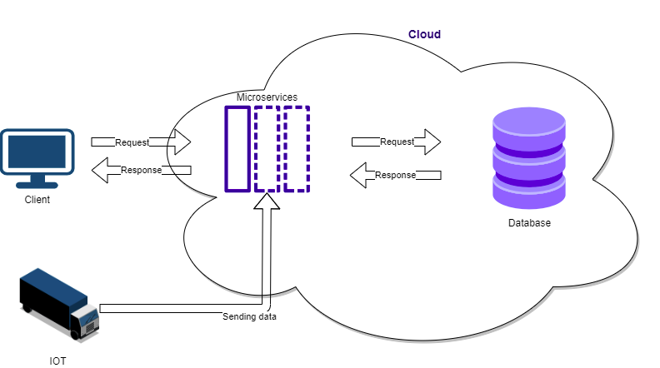

Figure 2: High Level System Architecture

Diagram for high level system architecture.

As showcased in the above image, in terms of the high-level architecture design we will expose an application program interface (API) to utilize our software. Our system will primarily follow microservice architecture with all the elements, principles and types in it for server-side development. Since our system is deployed on a cloud server, which clients can access from anywhere, it will be based on client server architecture for that part. The system will be following layered architecture because our system contains three layers:

1. Presentation layer
2. Business layer
3. Database layer

Presentation layer consists of the interface of the system developed in Quasar, a framework of vue.js. Business layer consists of the business logic of the system in spring boot microservices. Finally, we have the database layer containing all the data of the system, this layer uses Apache Ignite as a DBMS.

## Low-Level Architecture

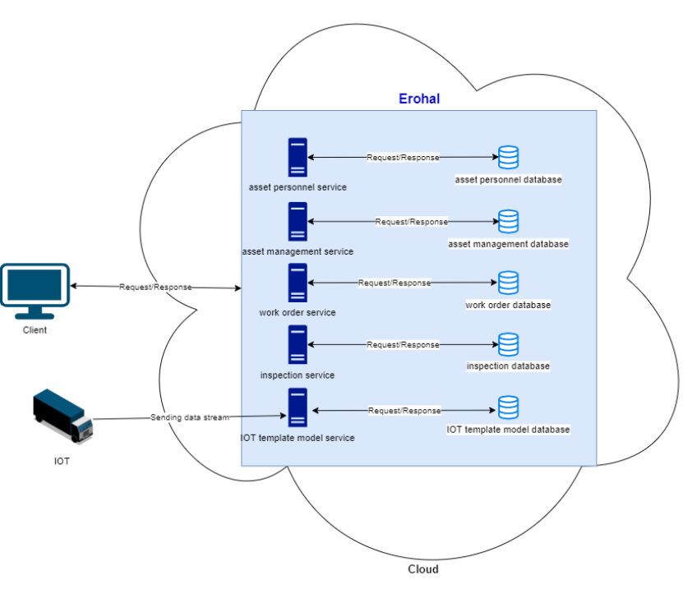

Figure 3: Low Level System Architecture

Diagram for low level system architecture.

As showcased in the above image, users will be able to send a request to the server in order to perform operations. The users have to first authenticate through our System residing in the cloud. Moreover, all services will be able to communicate with each other through Kafka calls [4]. Following data flow architecture, data from the IOT devices will be sent to IOT template model service, which then will be stored in its database and further passed on to inspection service for predictive maintenance.

## Component Diagram

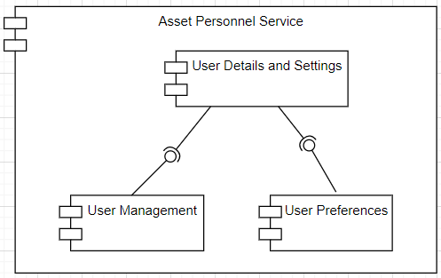

Figure 4: Asset Personnel Service Component

Component Diagram of Asset Personnel Service.

Asset personnel service primarily deals with user profile and settings. Apart from having user authentication details, user management and user preferences also make up this service. In the User management module, there are options to create a user or a user group, and also manage roles and permissions of a user, such as, giving all or selected/custom rights to each user. Whereas, in user preference, a user can set his basic preference related to language, currency, time zone etc. Finally, after the initial setup, a user will be able to view his profile and can add or modify his personal information and details, including his credentials.

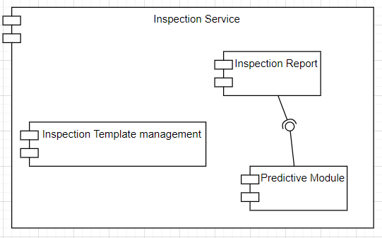

Figure 5: Inspection Service Component

Component Diagram of Inspection Service.

Inspection service components will include inspection template management, predictive module and inspection reports. Inspection template management will be responsible for creating and managing inspection templates that will be used in inspections of an asset. The predictive module will take previous history of an asset and its current data and provides information for predictive fault detection. Inspection report module will take predictive fault detection information and generate a report which can later be used for creating issues and work order assignment.

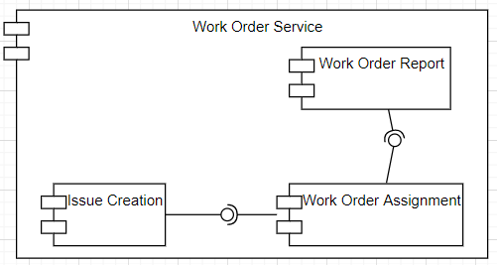

Figure 6: Works Order Service Component

Component Diagram of Work Order Service.

Work order service components will include issue creation, work order assignment and work order report. Issue creation will take input from an inspection report and generate an issue based on that inspection report. Work order assignment will assign the work order to relevant personnel based on the issues created by the issue creation module. Work order report will generate a report on maintenance of an asset.

# 

# Class Diagram

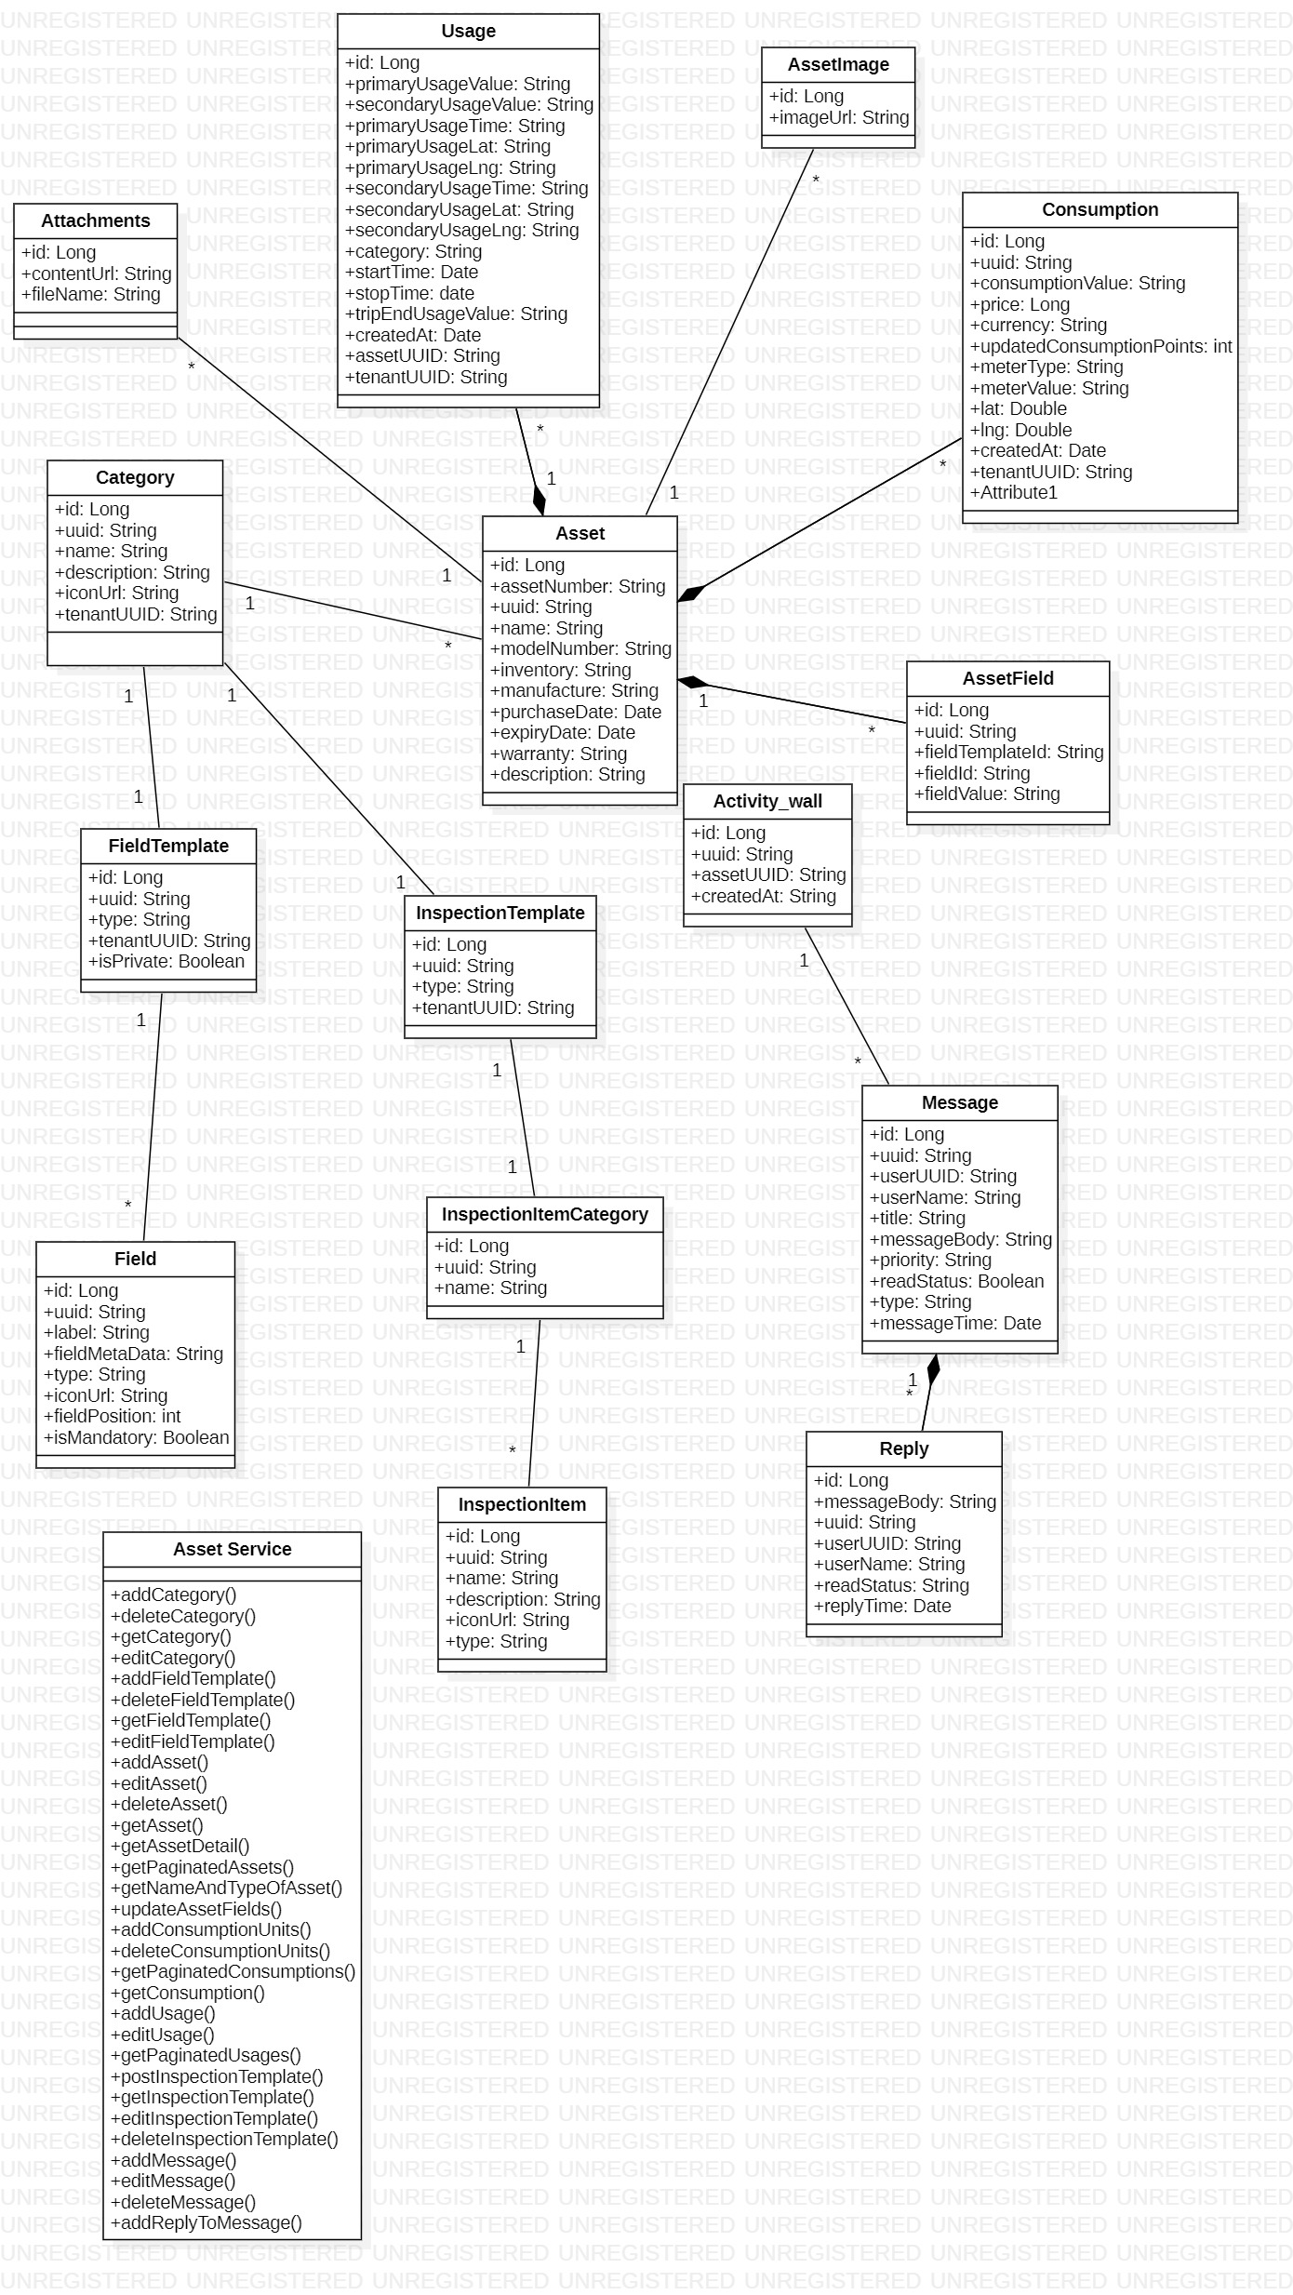

Figure 7: Asset Management Service

This is the class diagram of asset management service.

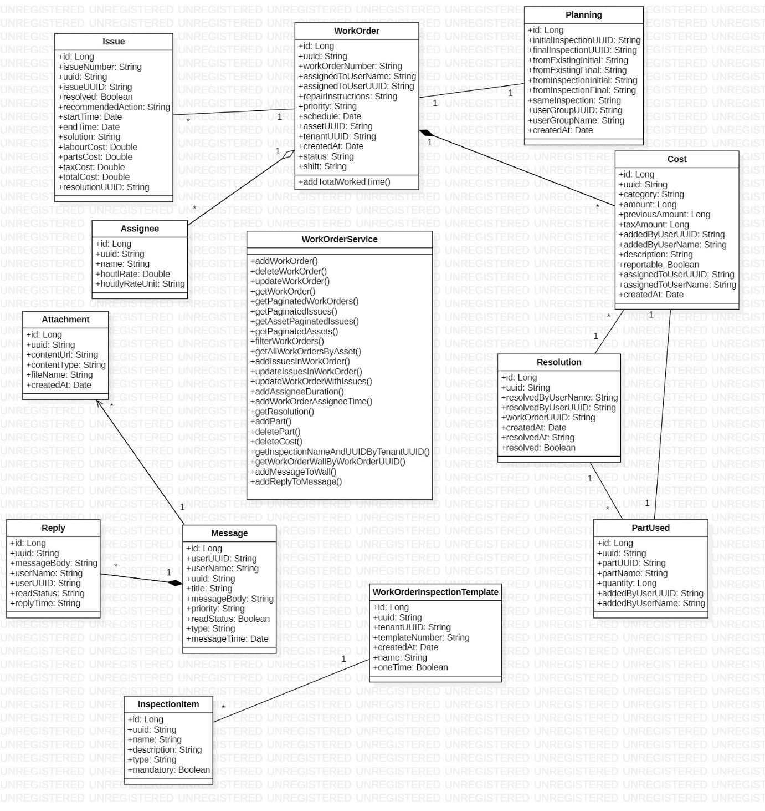

Figure 8: Work Order Service

This is the class diagram of work order service.

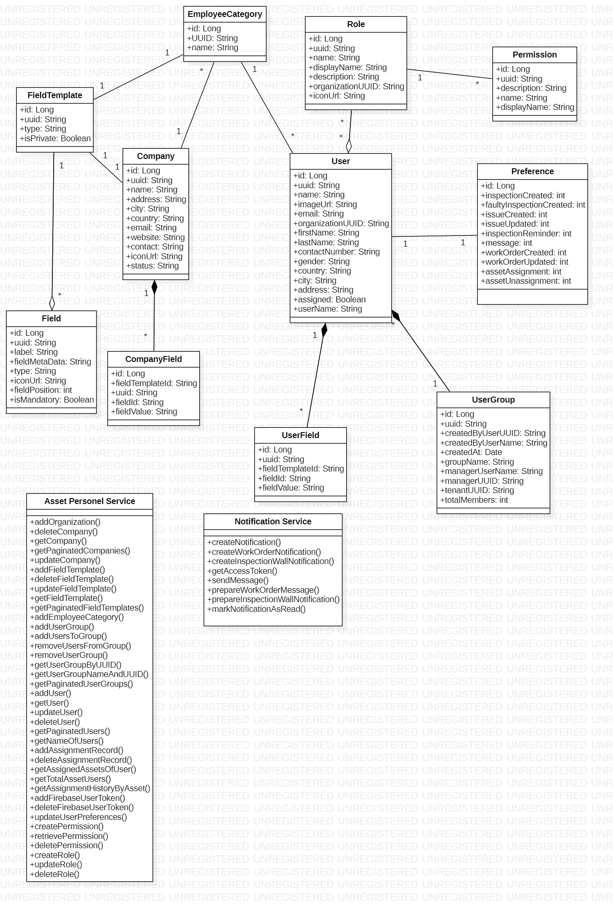

Figure 9: Asset Personnel Service

This is the class diagram of asset personnel service.

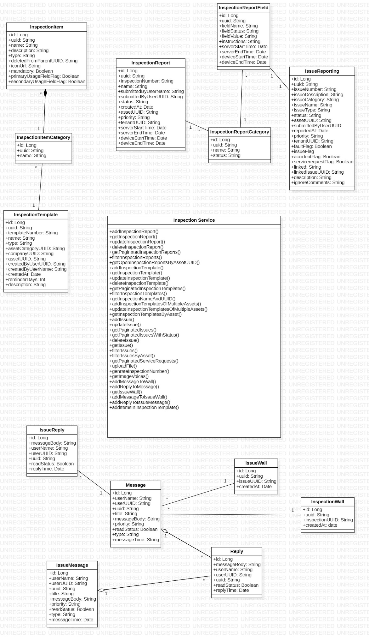

Figure 10: Inspection Service

This is the class diagram of inspection service.

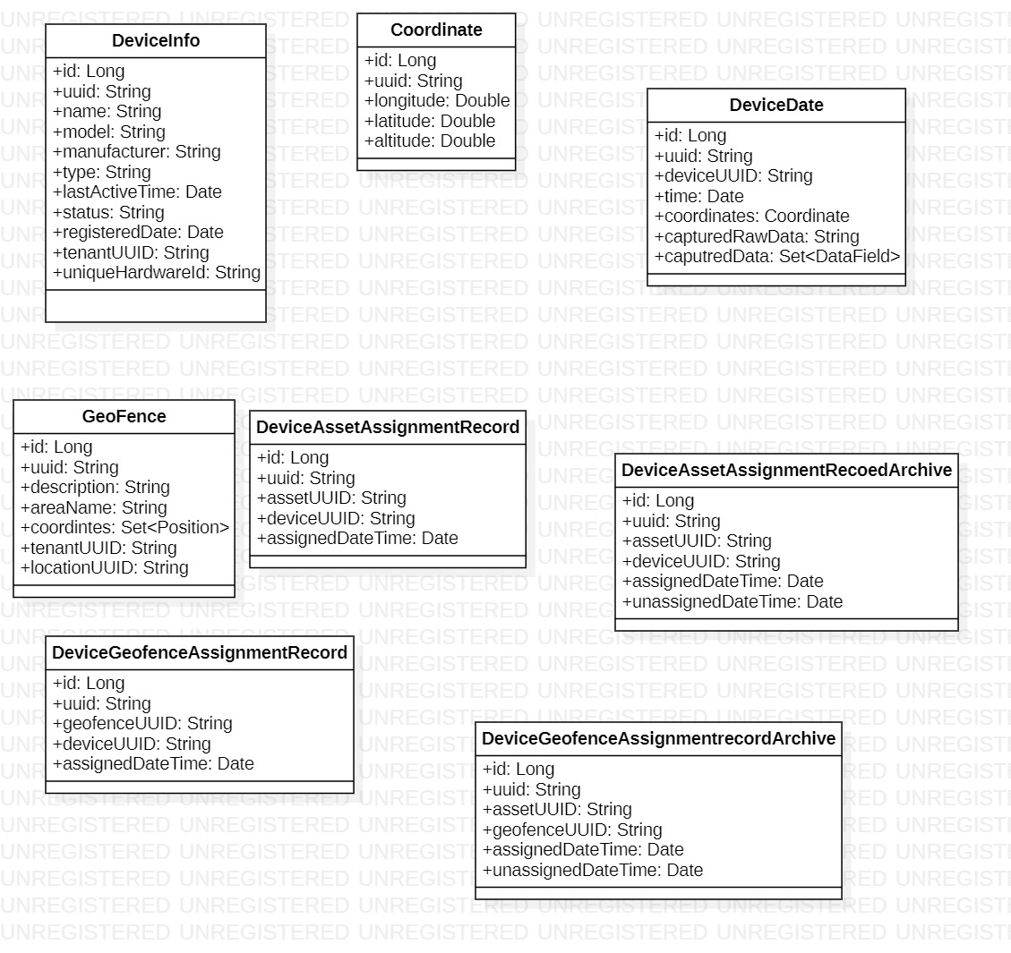

Figure 11: Device Template Service

This is the class diagram of device template service.

# Sequence Diagrams

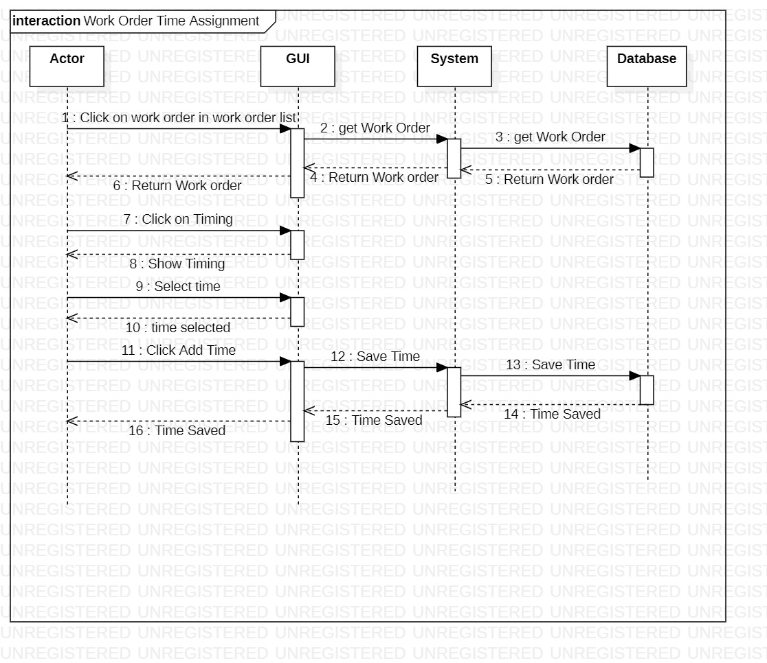

Figure 12: Work Order Time Assignment

This is the sequence diagram of work order time assignment.

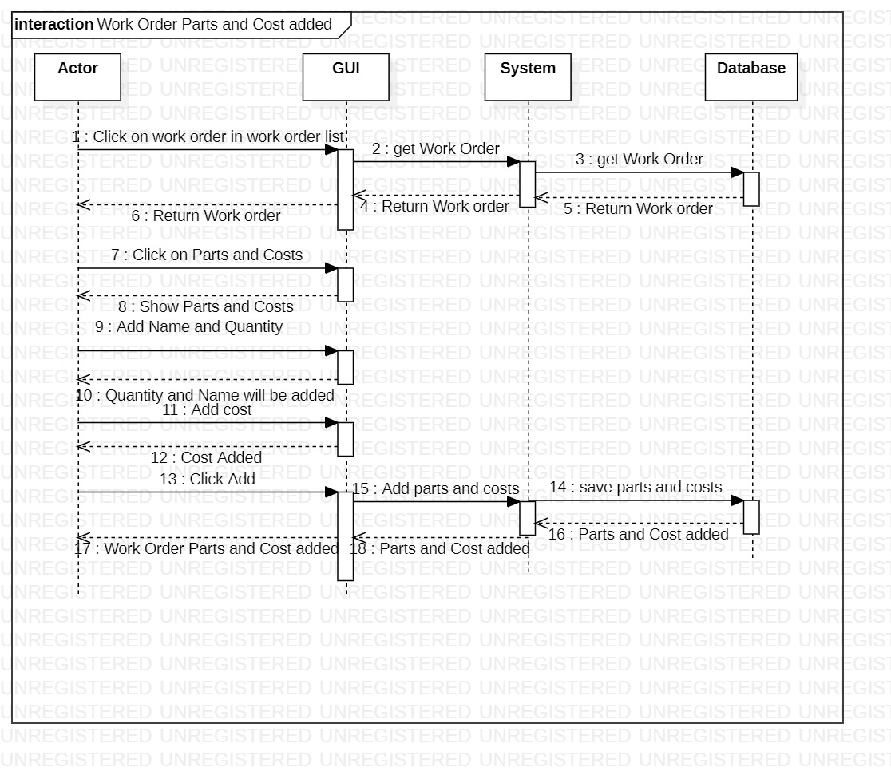

Figure 13: Work Order Parts and Cost added

This is the sequence diagram of work order parts and cost.

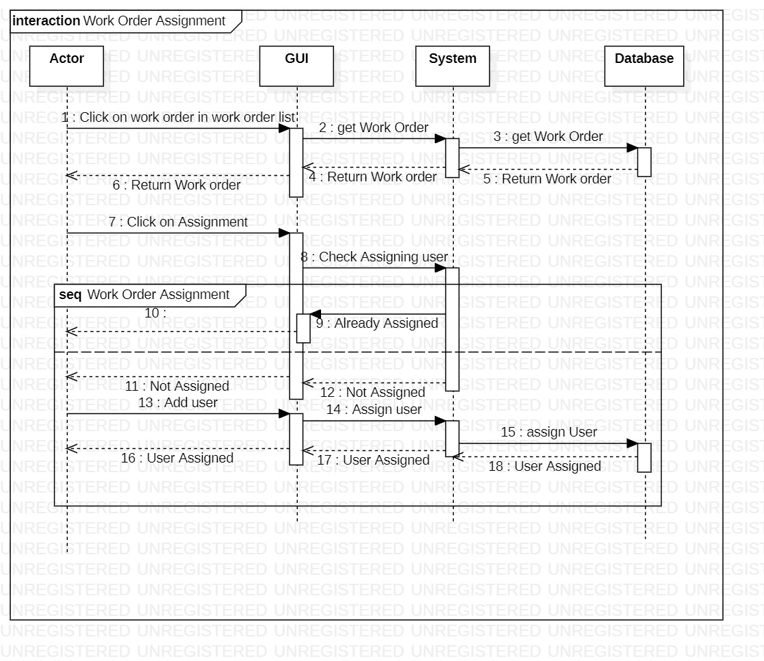

Figure 14: Work Order Assignment

This is the sequence diagram of work order assignment.

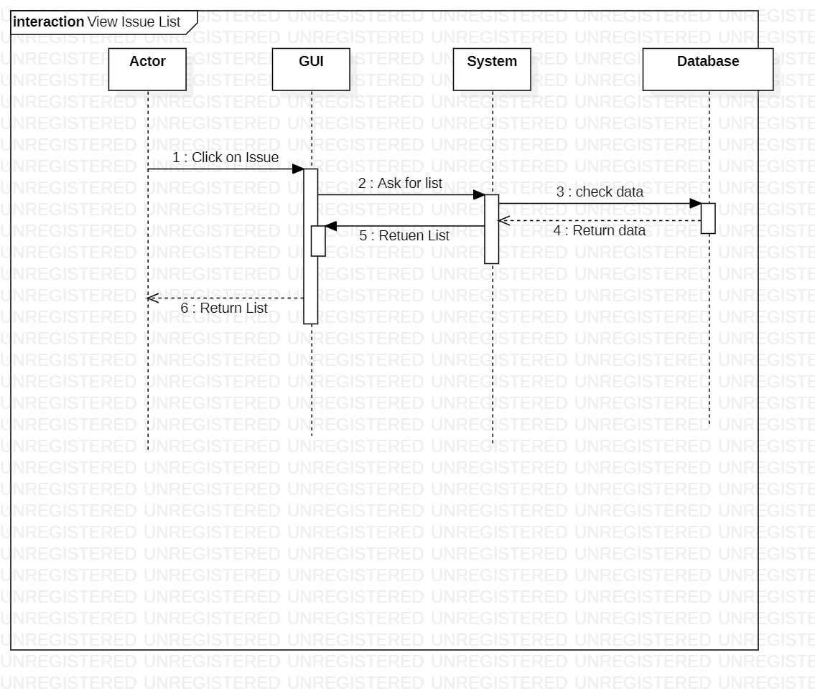

Figure 15: View Issue List

This is the sequence diagram of view issue list.

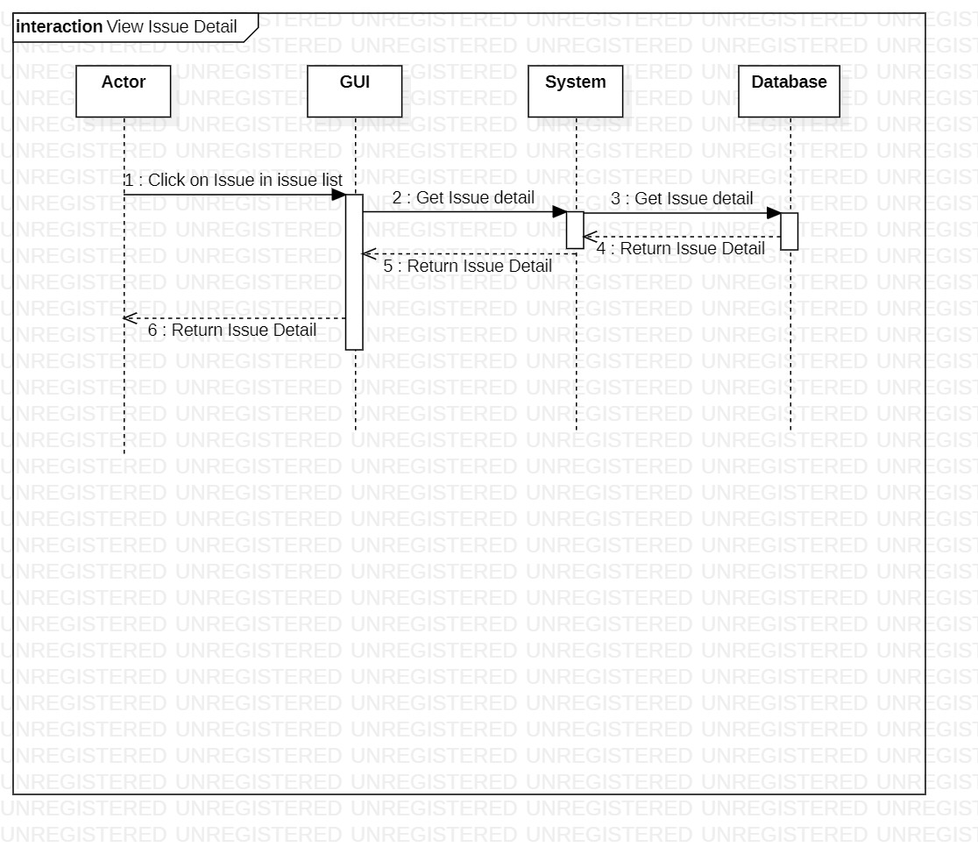

Figure 16: View Issue Detail

This is the sequence diagram of view issue detail.

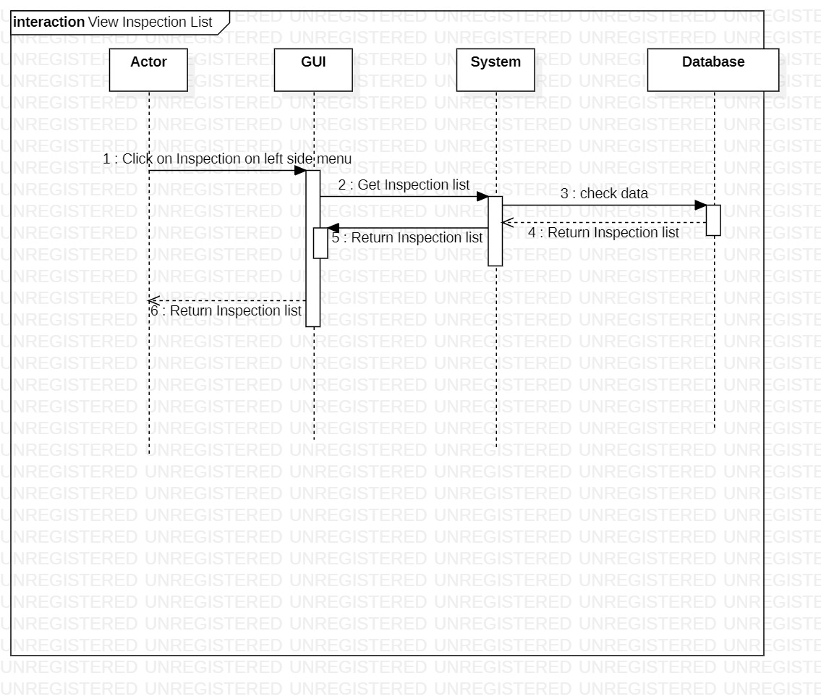

Figure 17: View Inspection List

This is the sequence diagram of view inspection list.

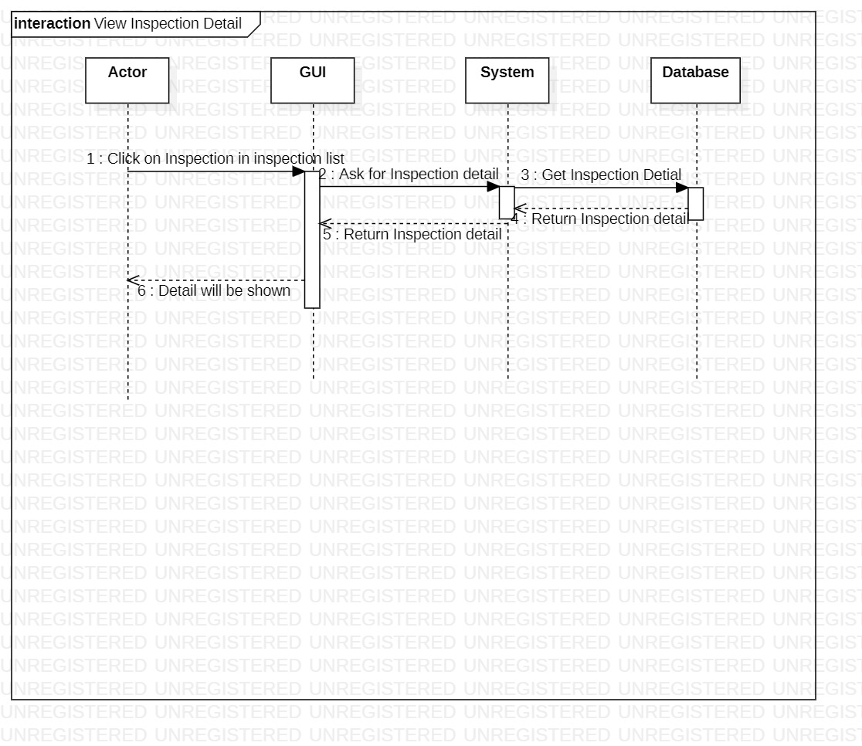

Figure 18: View Inspection Detail

This is the sequence diagram of view inspection detail.

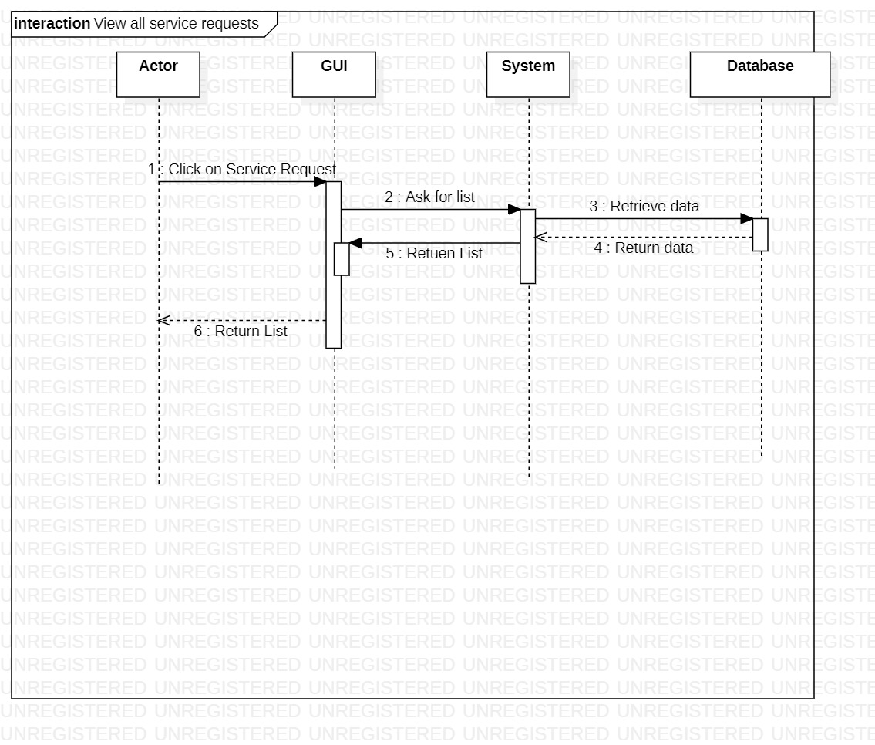

Figure 19: View All Service Requests

This is the sequence diagram of view all service requests.

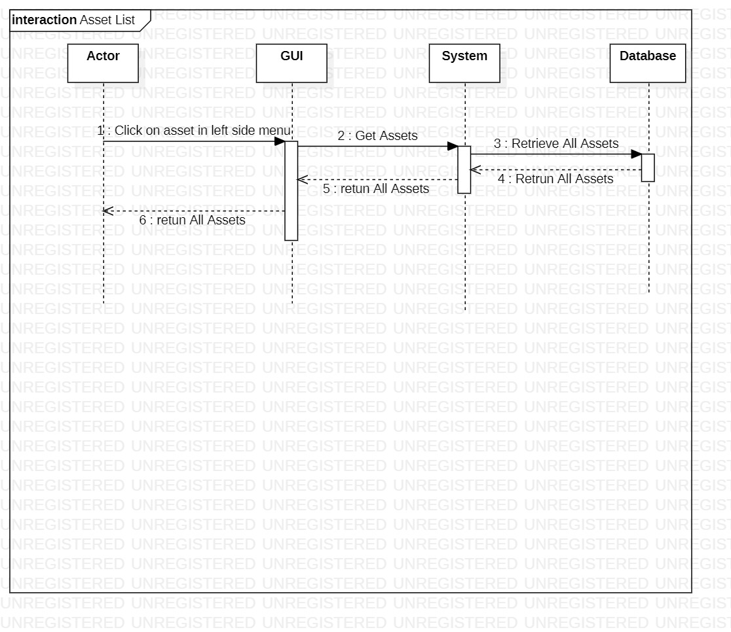

Figure 20: Asset List

This is the sequence diagram of asset list.

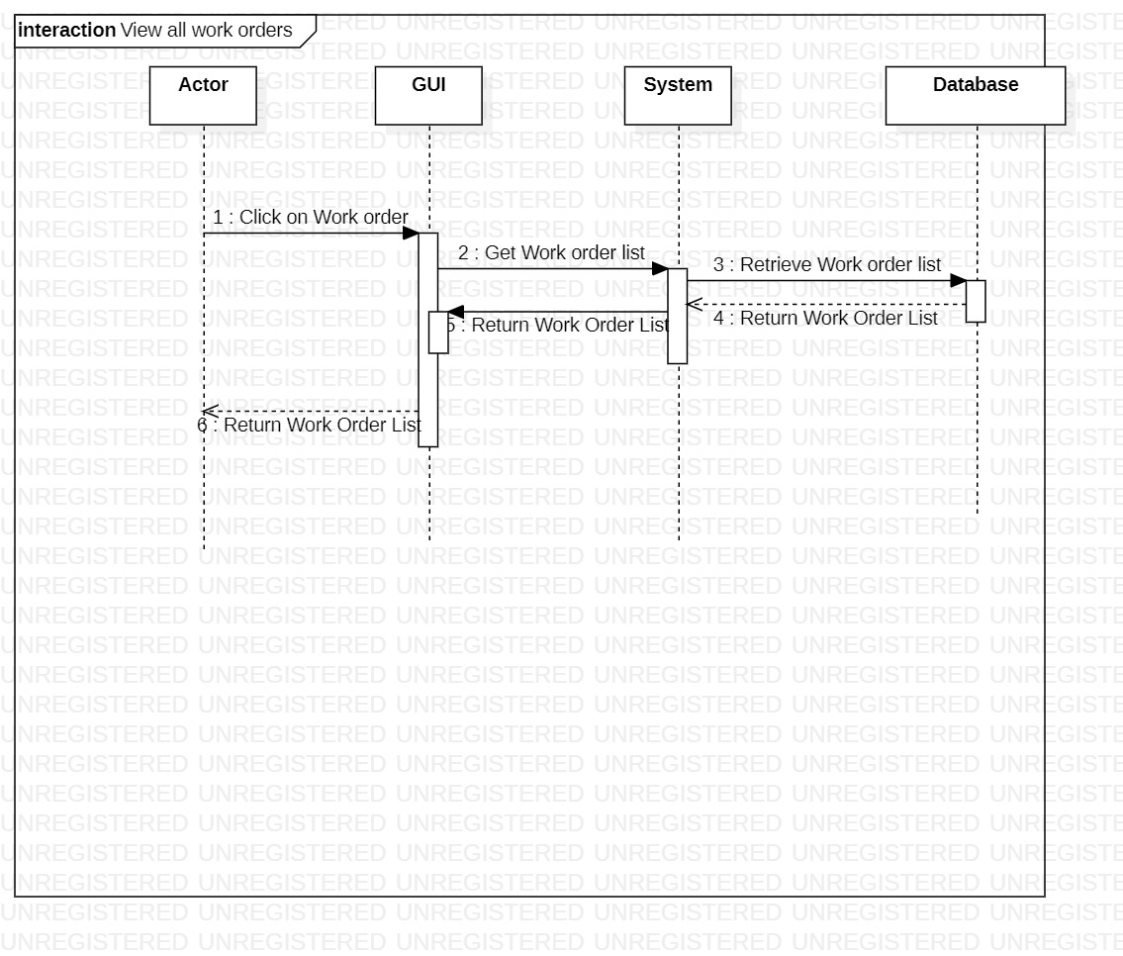

Figure 21: View All Work Orders

This is the sequence diagram of view work orders.

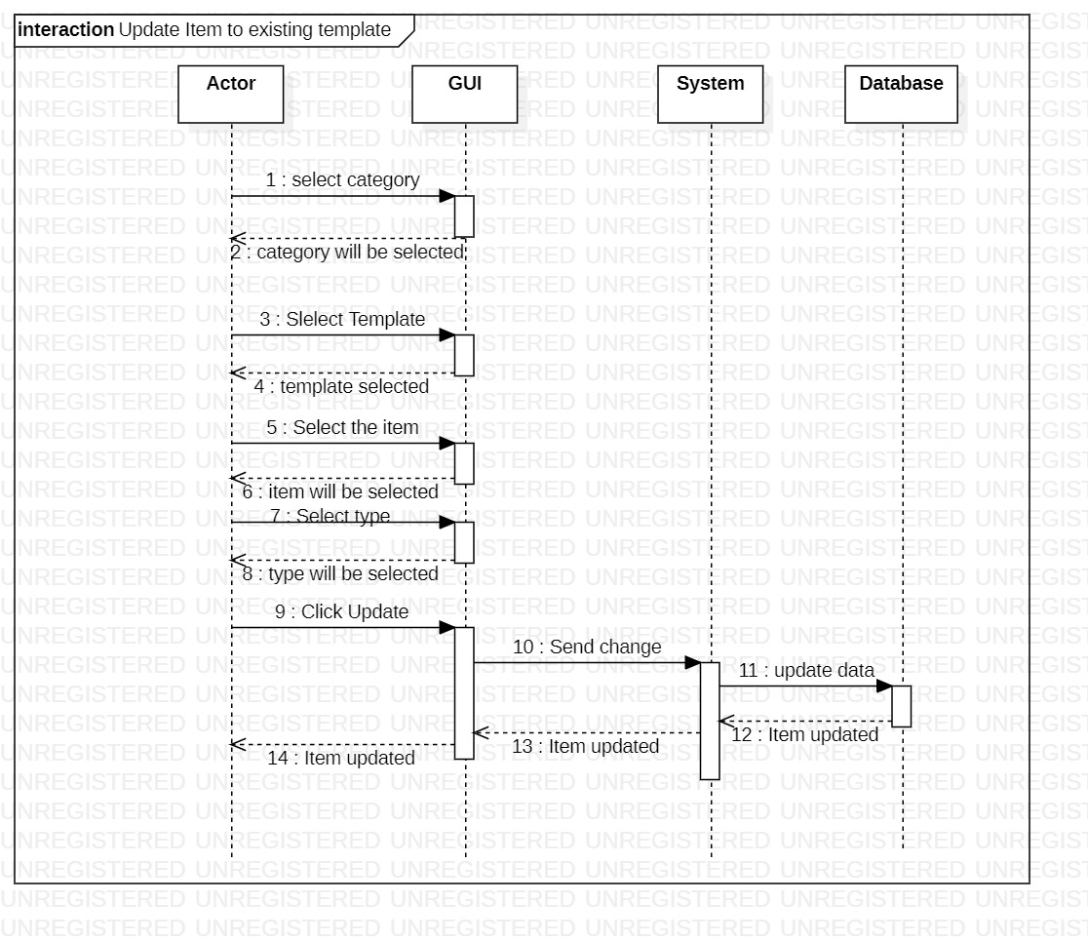

Figure 22: Update Item to Existing Template

This is the sequence diagram of update item to existing template.

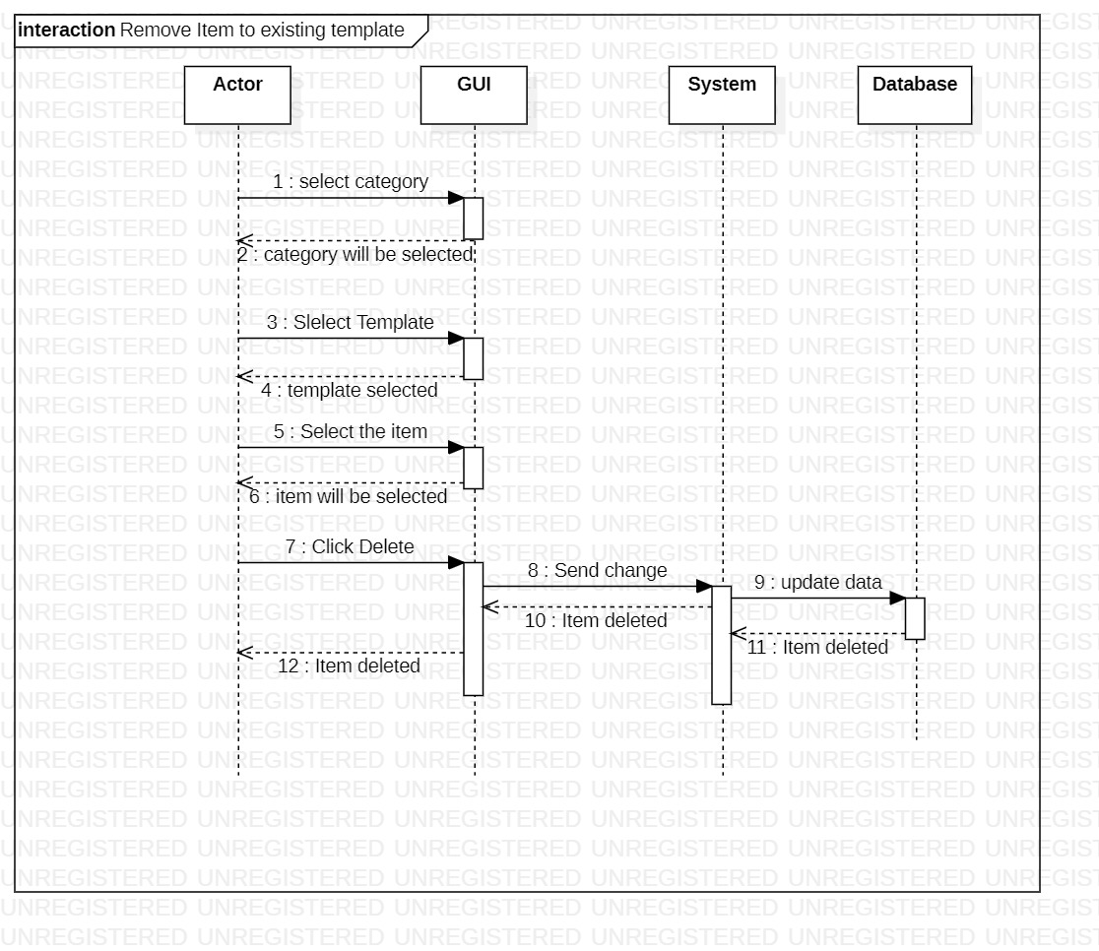

Figure 23: Remove Item to Existing Template

This is the sequence diagram of remove item to existing template.

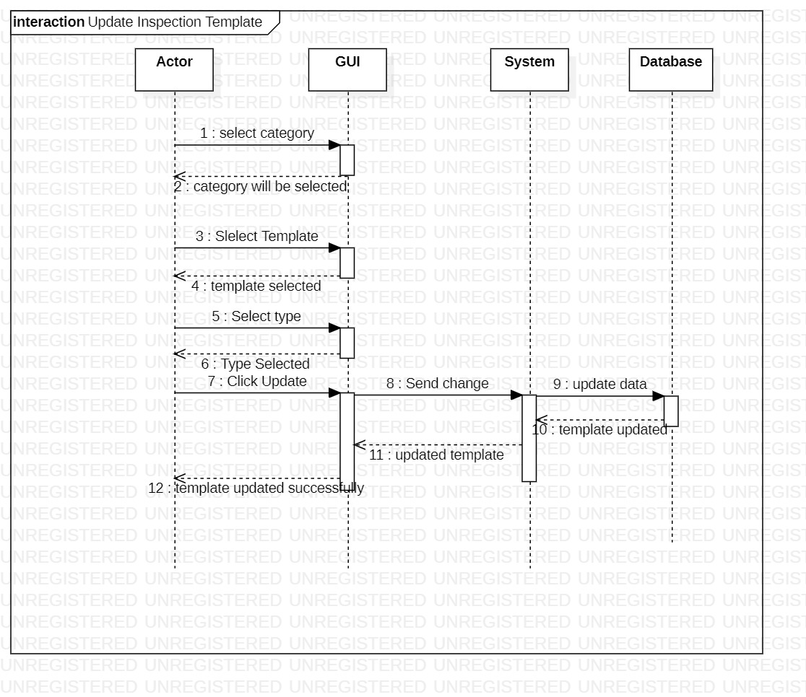

Figure 24: Update Inspection Template

This is the sequence diagram of update inspection template.

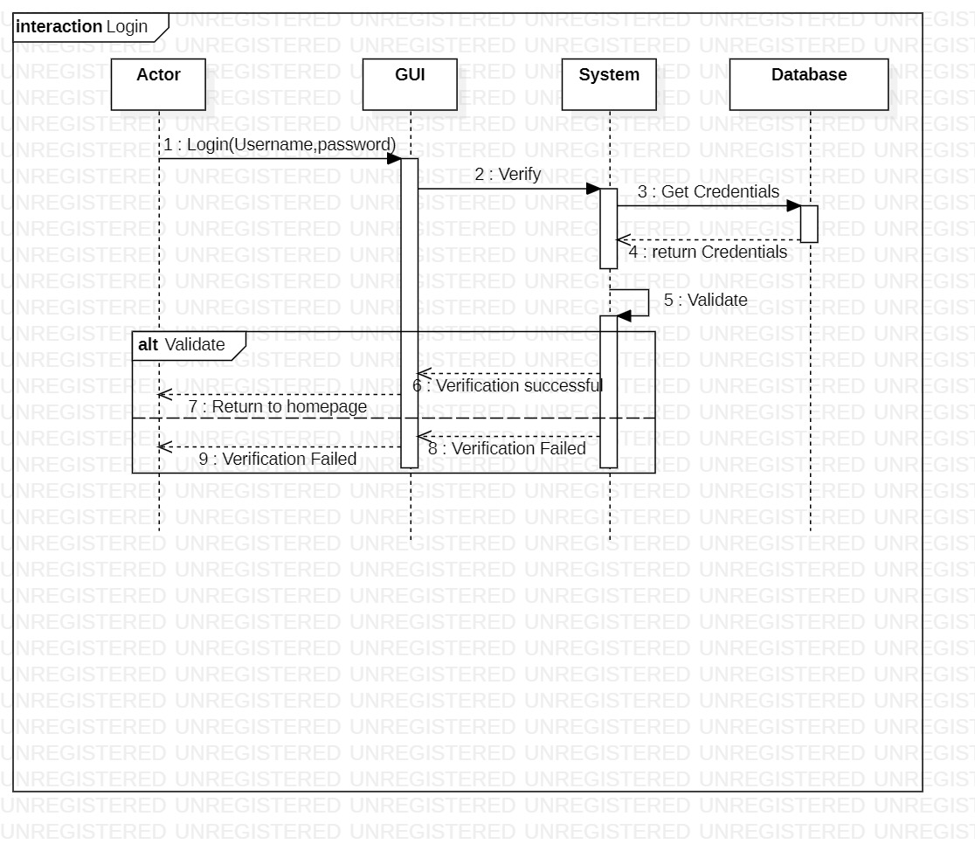

Figure 25: Login

This is the sequence diagram of login.

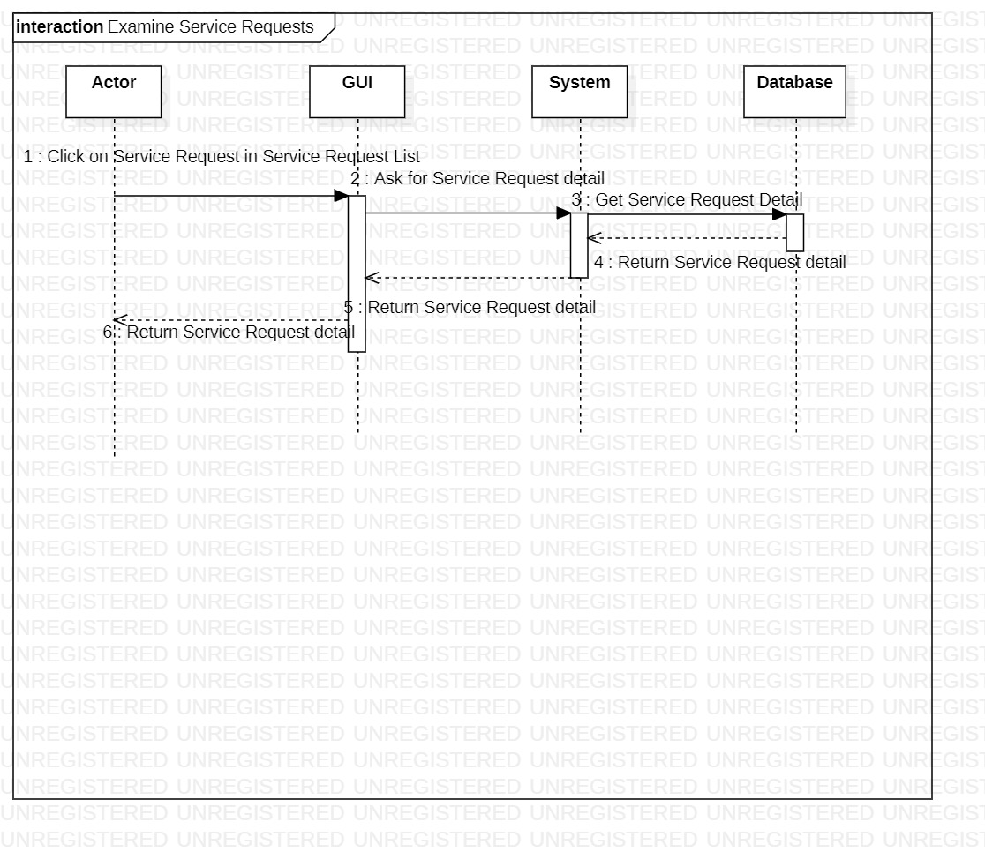

Figure 26: Examine Service Requests

This is the sequence diagram of examine service requests.

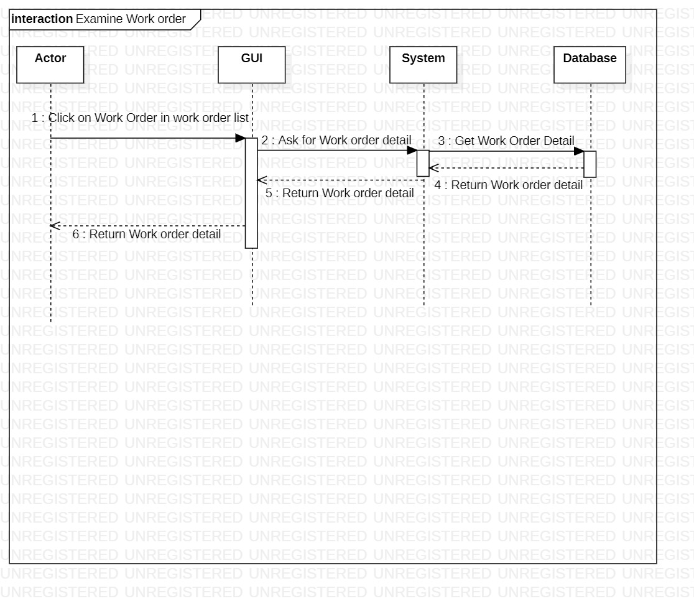

Figure 27: Examine Work Order

This is the sequence diagram of examine work order.

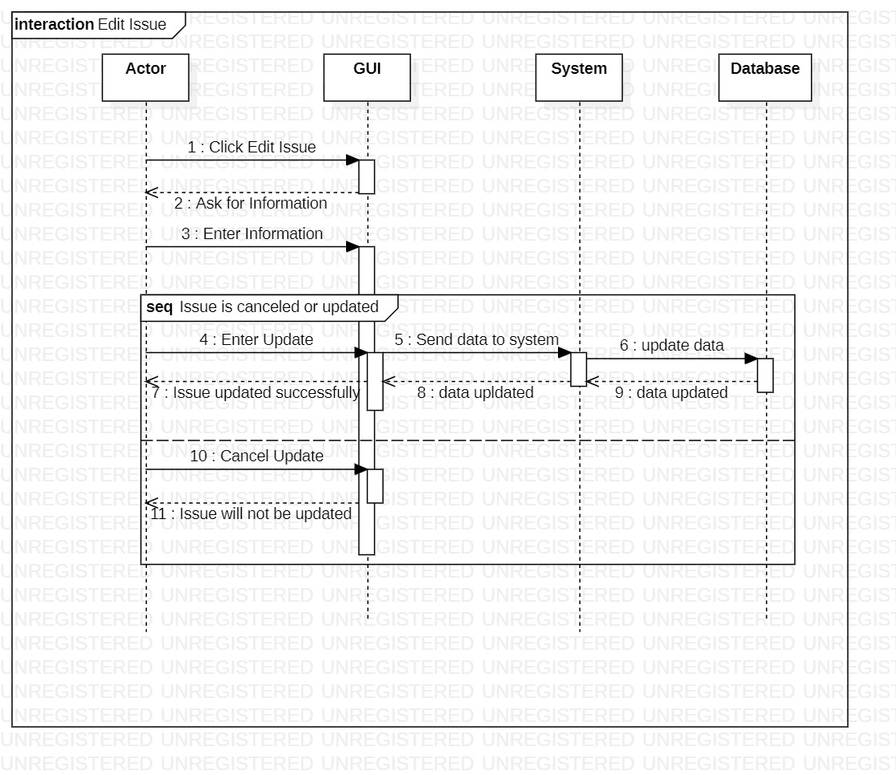

Figure 28: Edit Issue

This is the sequence diagram of edit issue.

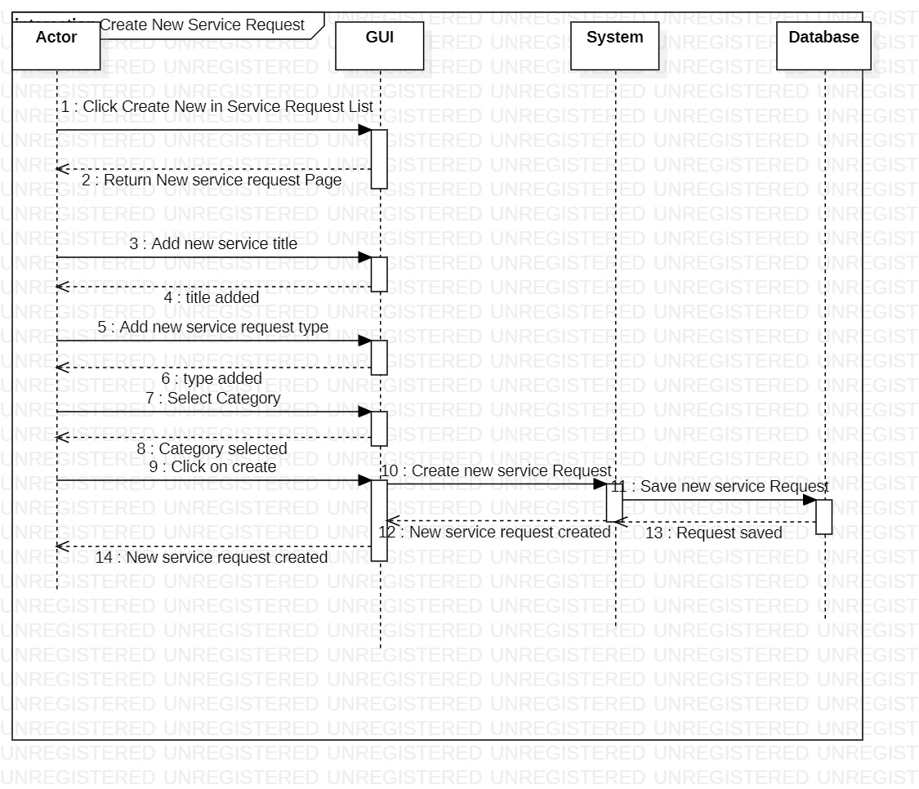

Figure 29: Create New Service Request

This is the sequence diagram of create new service request.

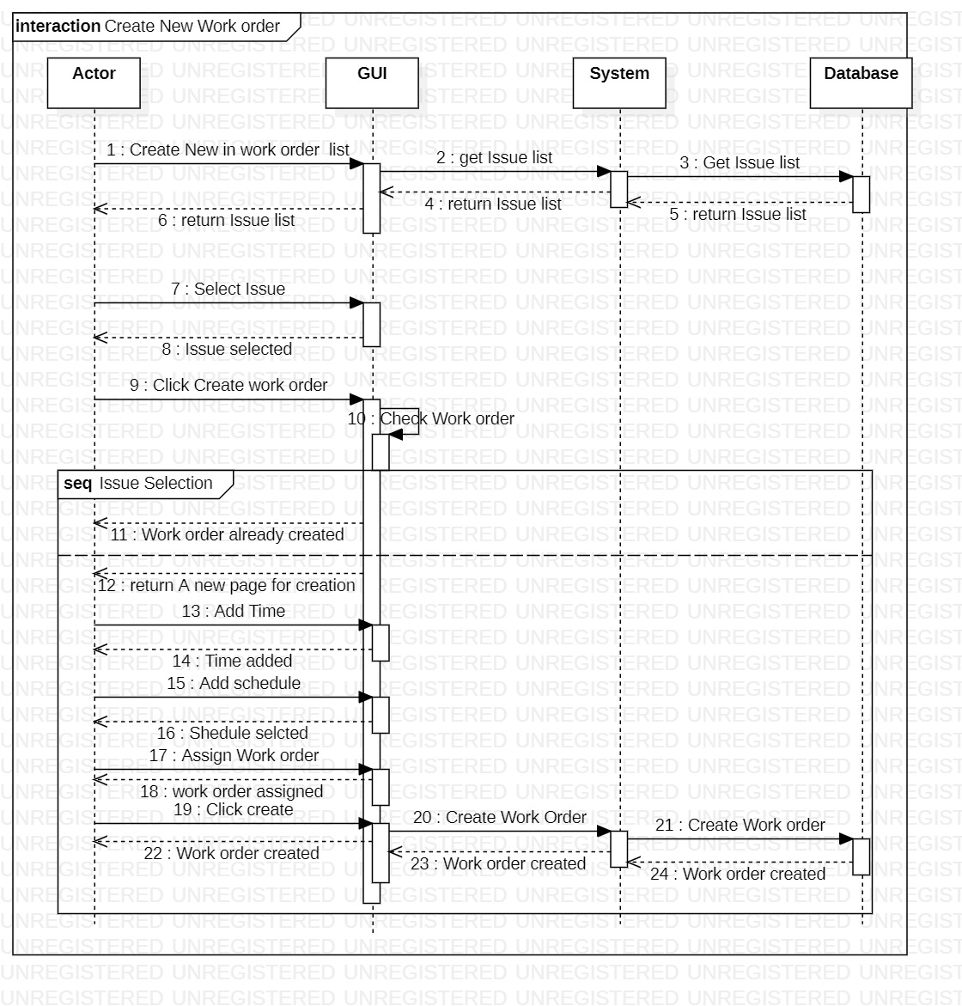

Figure 30: Create New Work Order

This is the sequence diagram of create new work order.

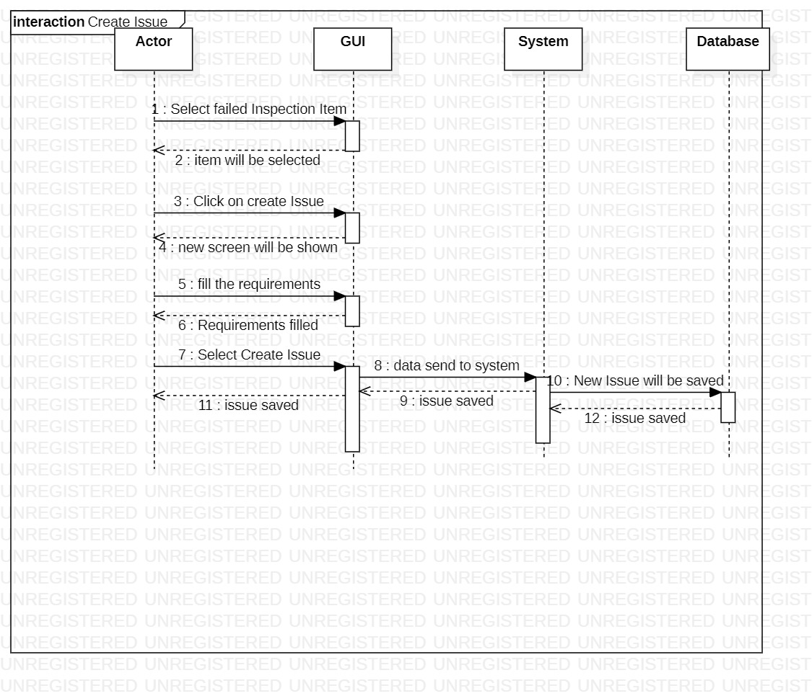

Figure 31: Create Issue

This is the sequence diagram of create issue.

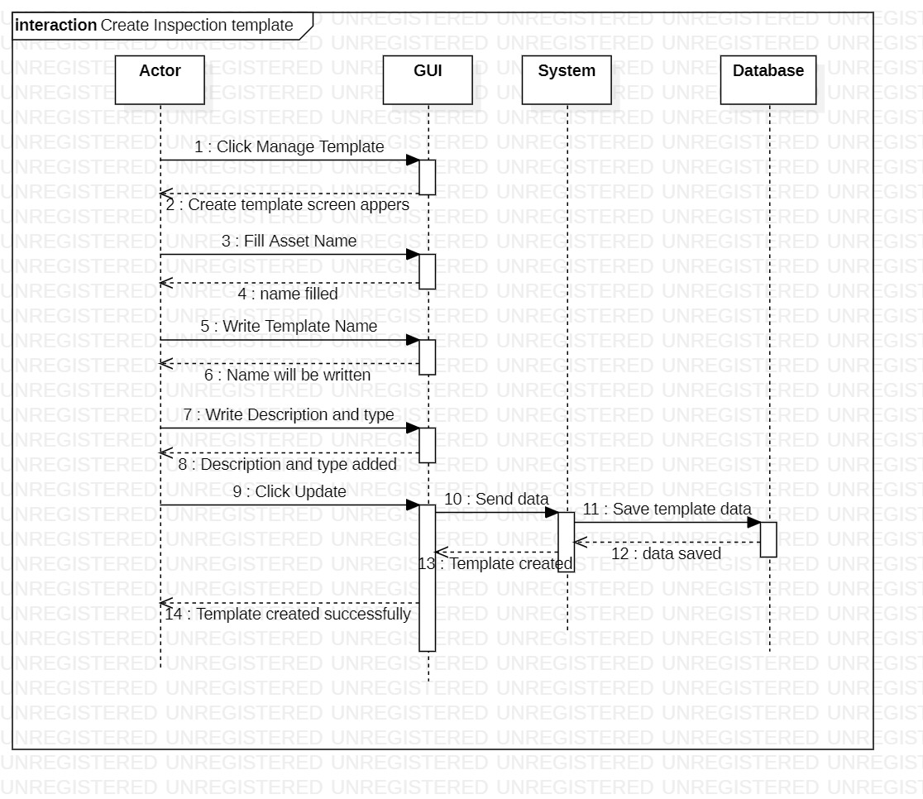

Figure 32: Create Inspection Template

This is the sequence diagram of create inspection template.

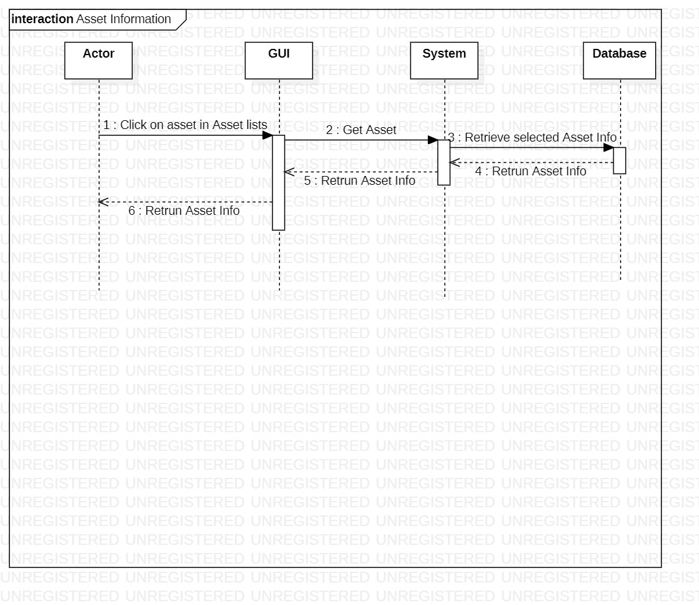

Figure 33: Asset Information

This is the sequence diagram of asset information.

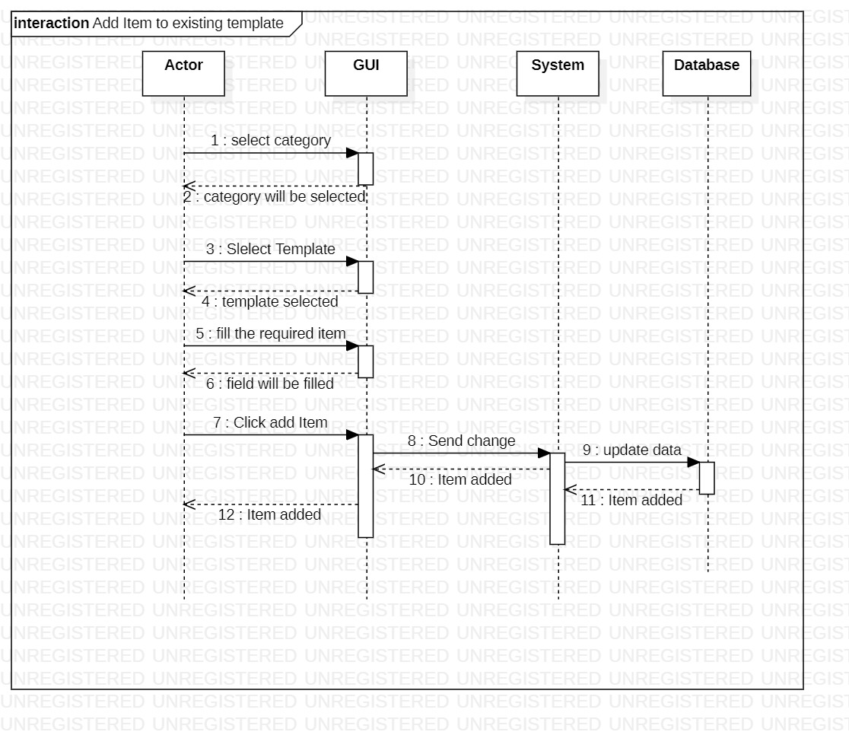

Figure 34: Add Item to Existing Template

This is the sequence diagram of add item to existing template.

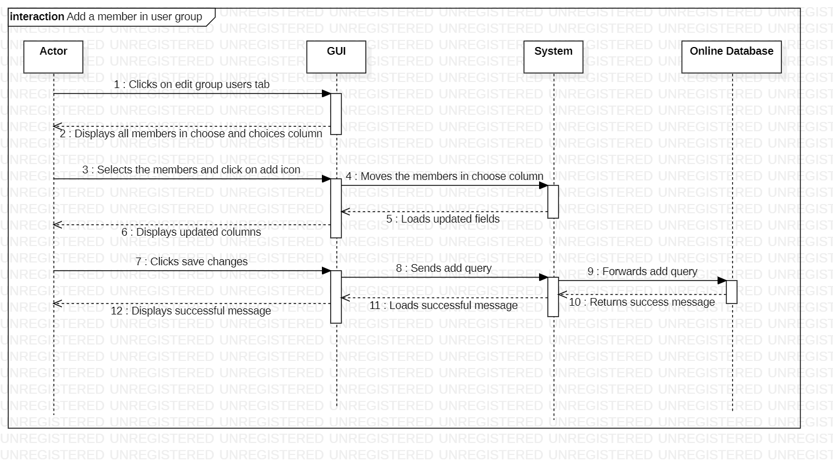

Figure 35: Add a Member in User Group

This is the sequence diagram of add a member in user group.

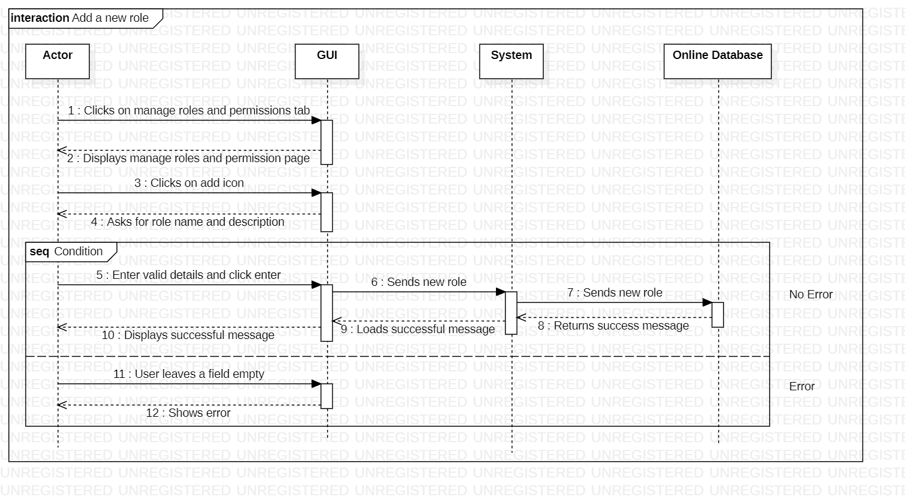

Figure 36: Add a New Role

This is the sequence diagram of add a new role.

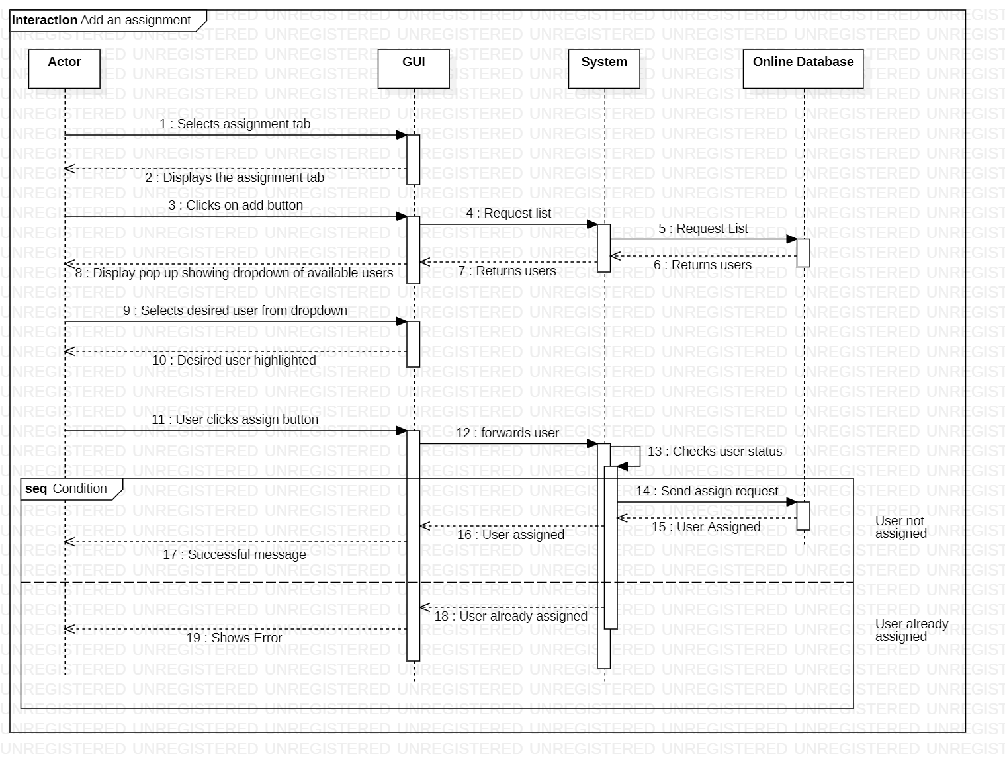

Figure 37: Add an Assignment

This is the sequence diagram of add an assignment.

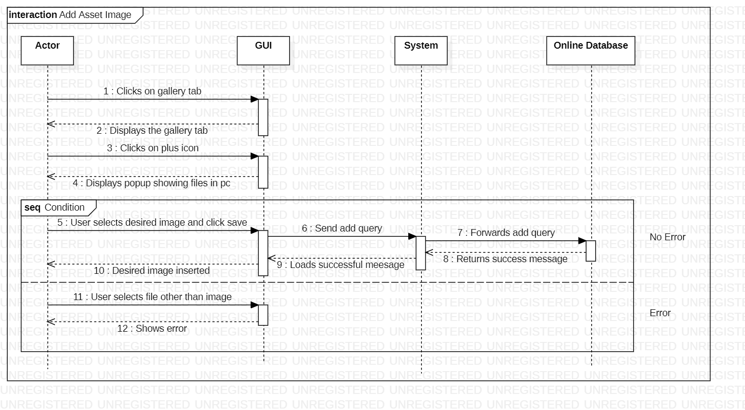

Figure 38: Add an Asset Image

This is the sequence diagram of add an asset image.

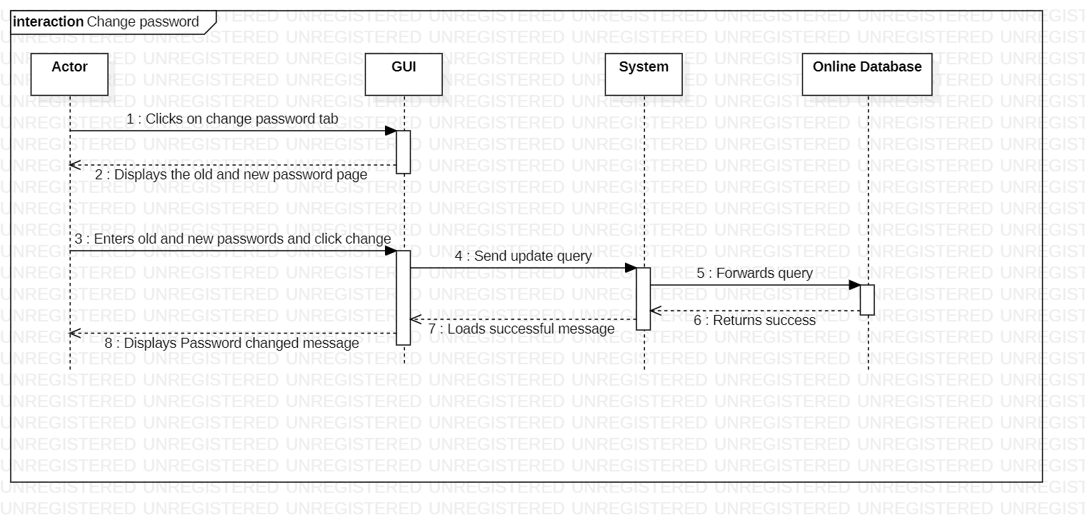

Figure 39: Change Password

This is the sequence diagram of change password.

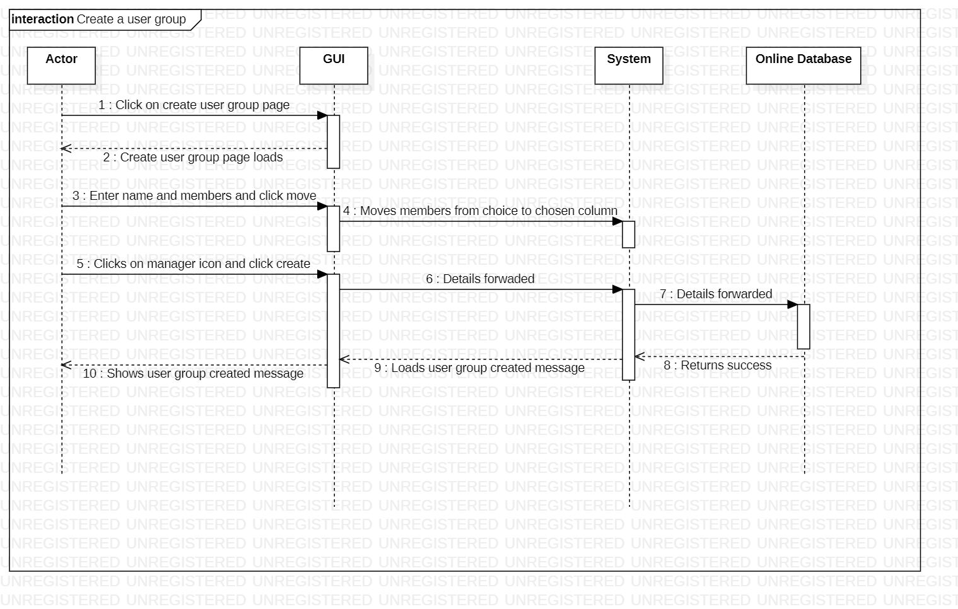

Figure 40: Create a User group

This is the sequence diagram of create a user group.

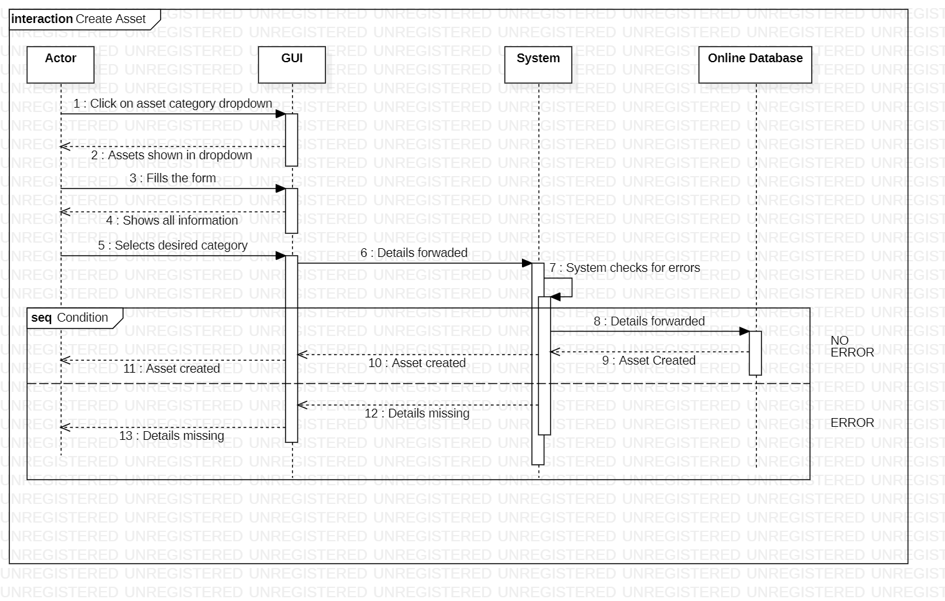

Figure 41: Create Asset

This is the sequence diagram of create asset.

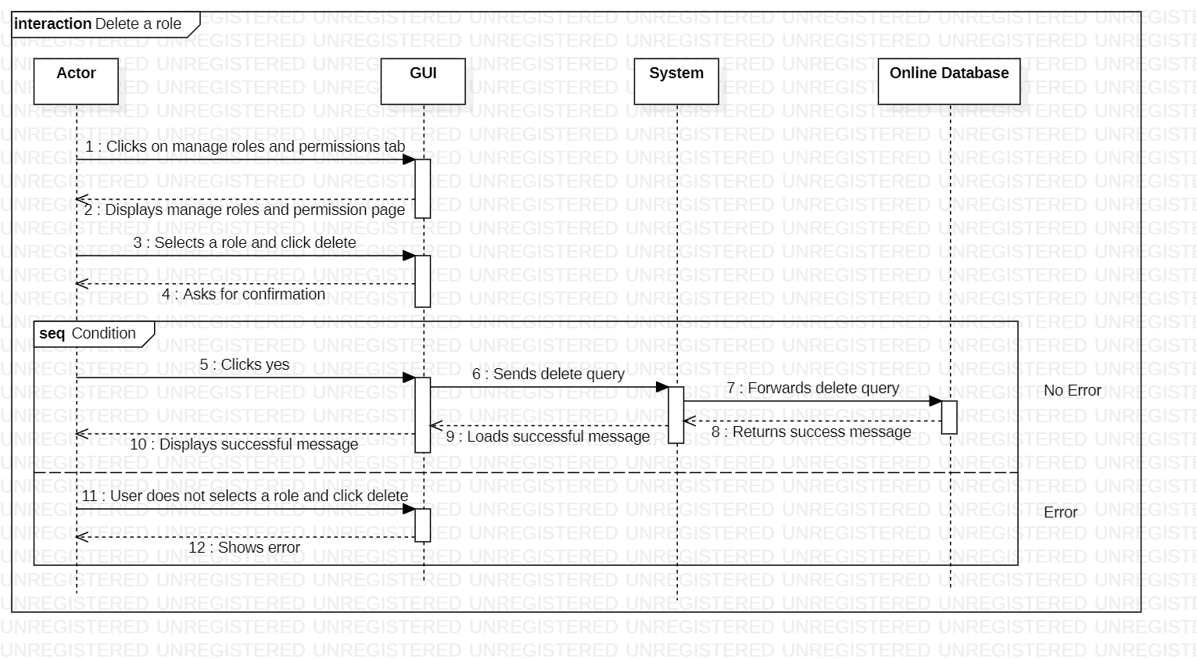

Figure 42: Delete a Role

This is the sequence diagram of delete a role.

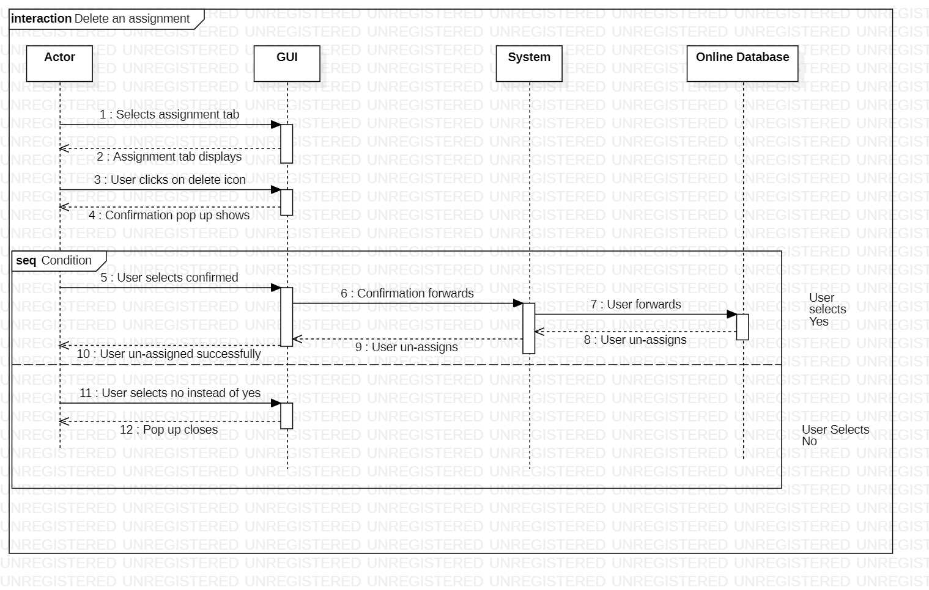

Figure 43: Delete an Assignment

This is the sequence diagram of delete an assignment

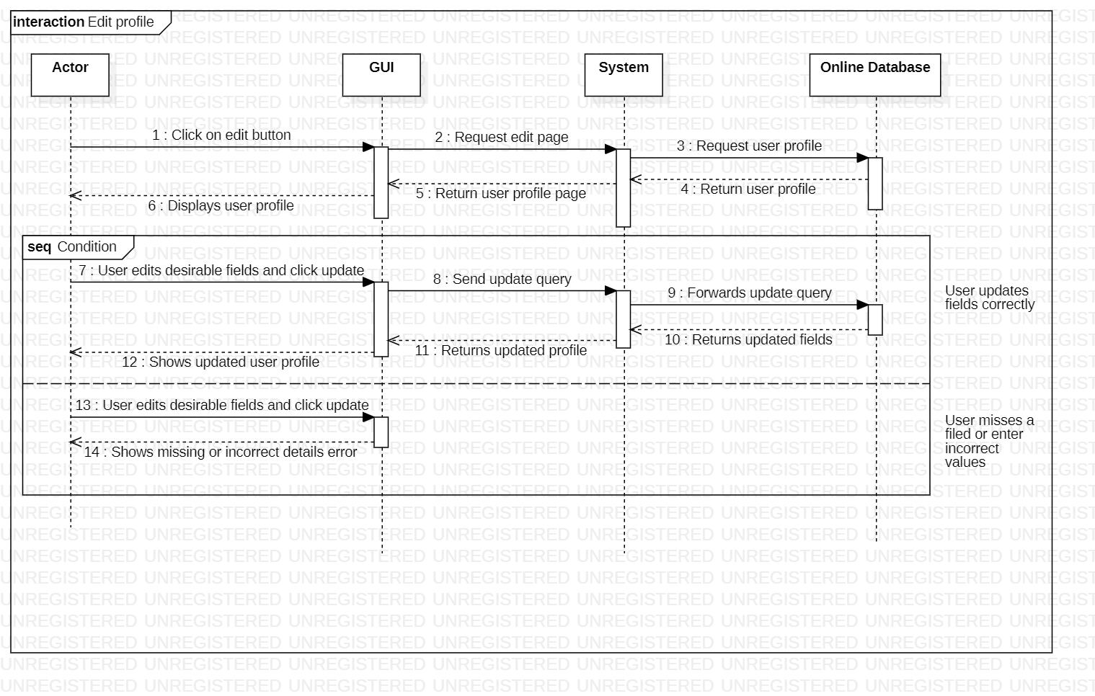

Figure 44: Edit a Profile

This is the sequence diagram of edit a profile.

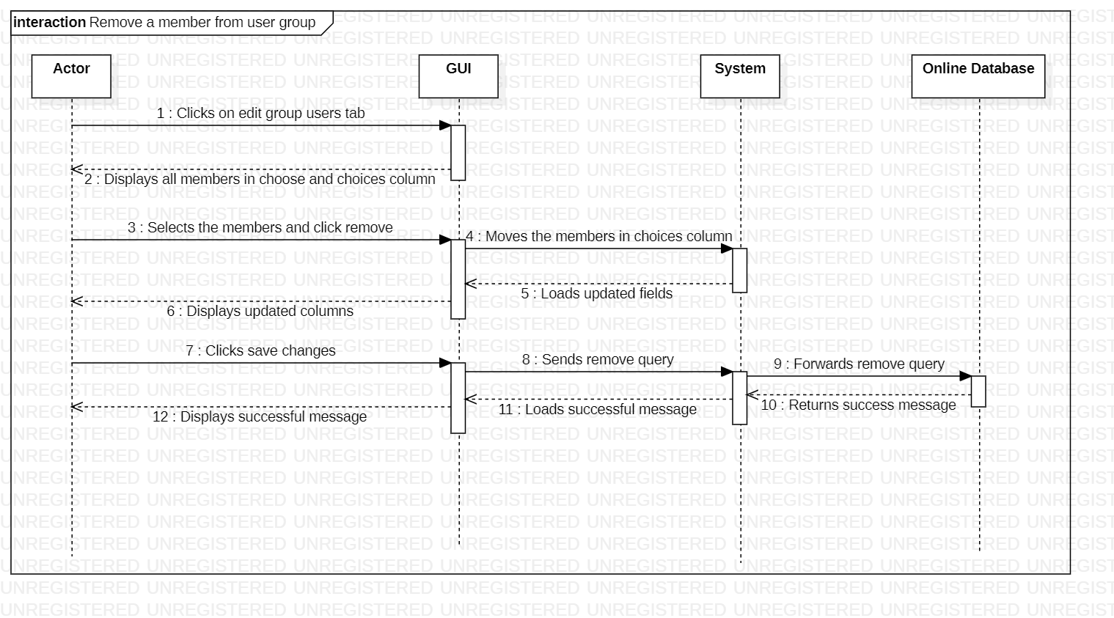

Figure 45: Remove a Member from User Group

This is the sequence diagram of remove a member from user group.

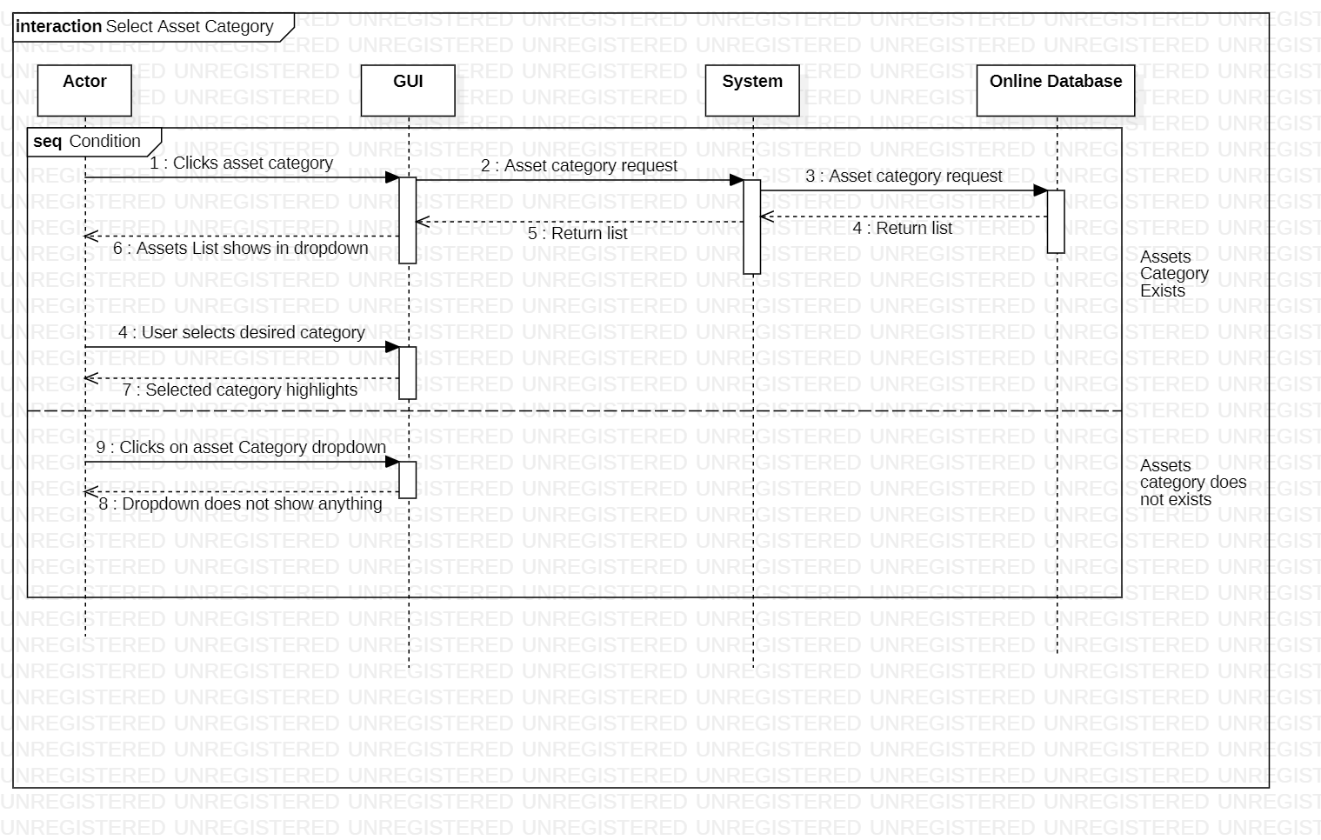

Figure 46: Select Asset Category

This is the sequence diagram of select an asset category.

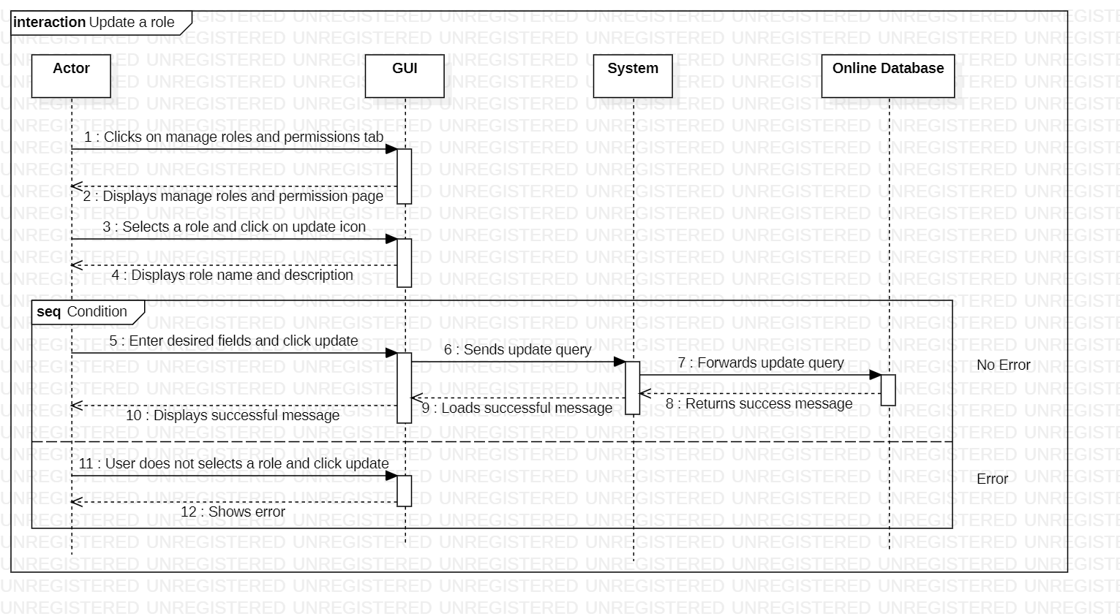

Figure 47: Update a Role

This is the sequence diagram of update a role.

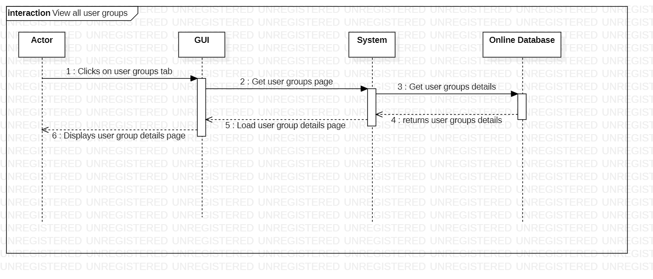

Figure 48: View All User Groups

This is the sequence diagram of view all user groups.

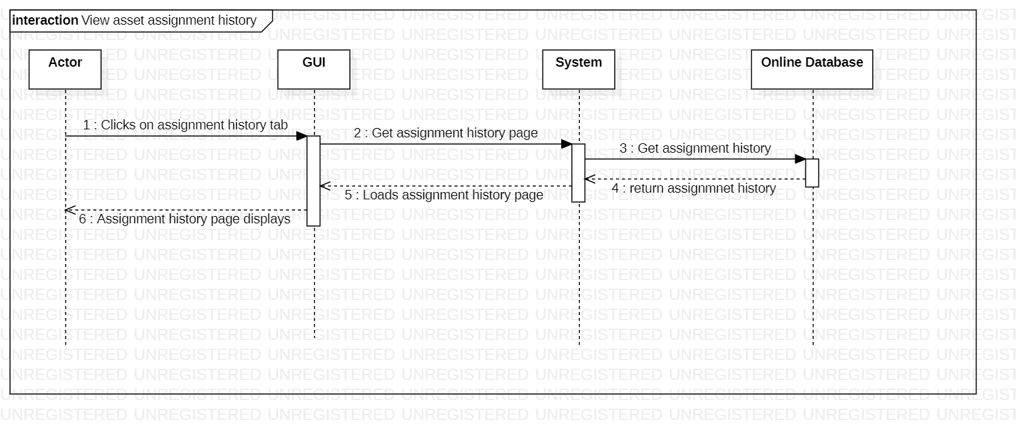

Figure 49: View Asset Assignment History

This is the sequence diagram of view asset assignment history.

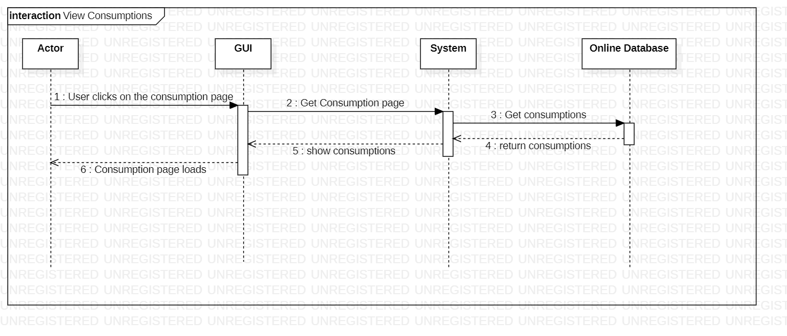

Figure 50: View Consumptions

This is the sequence diagram of view consumptions.

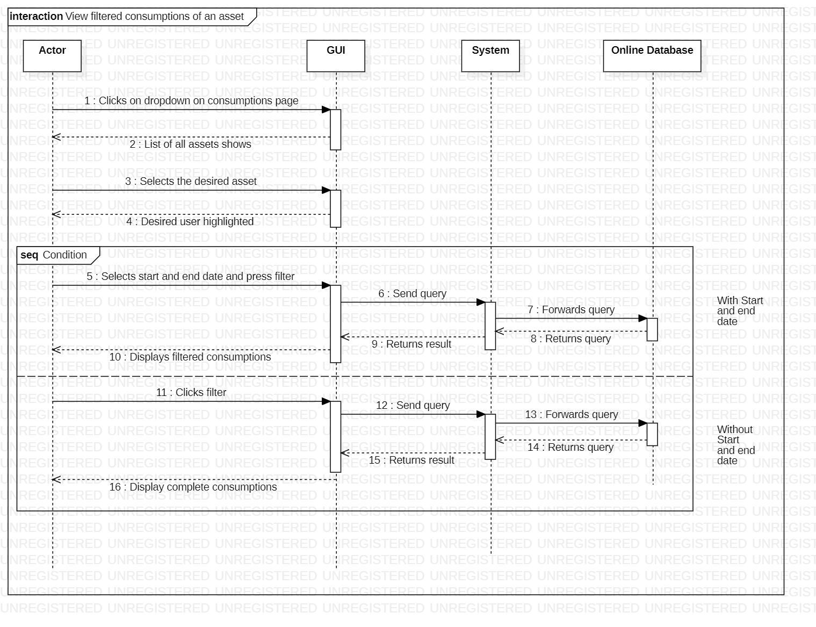

Figure 51: View Filtered Consumptions of an Asset

This is the sequence diagram of view filtered consumptions of an asset.

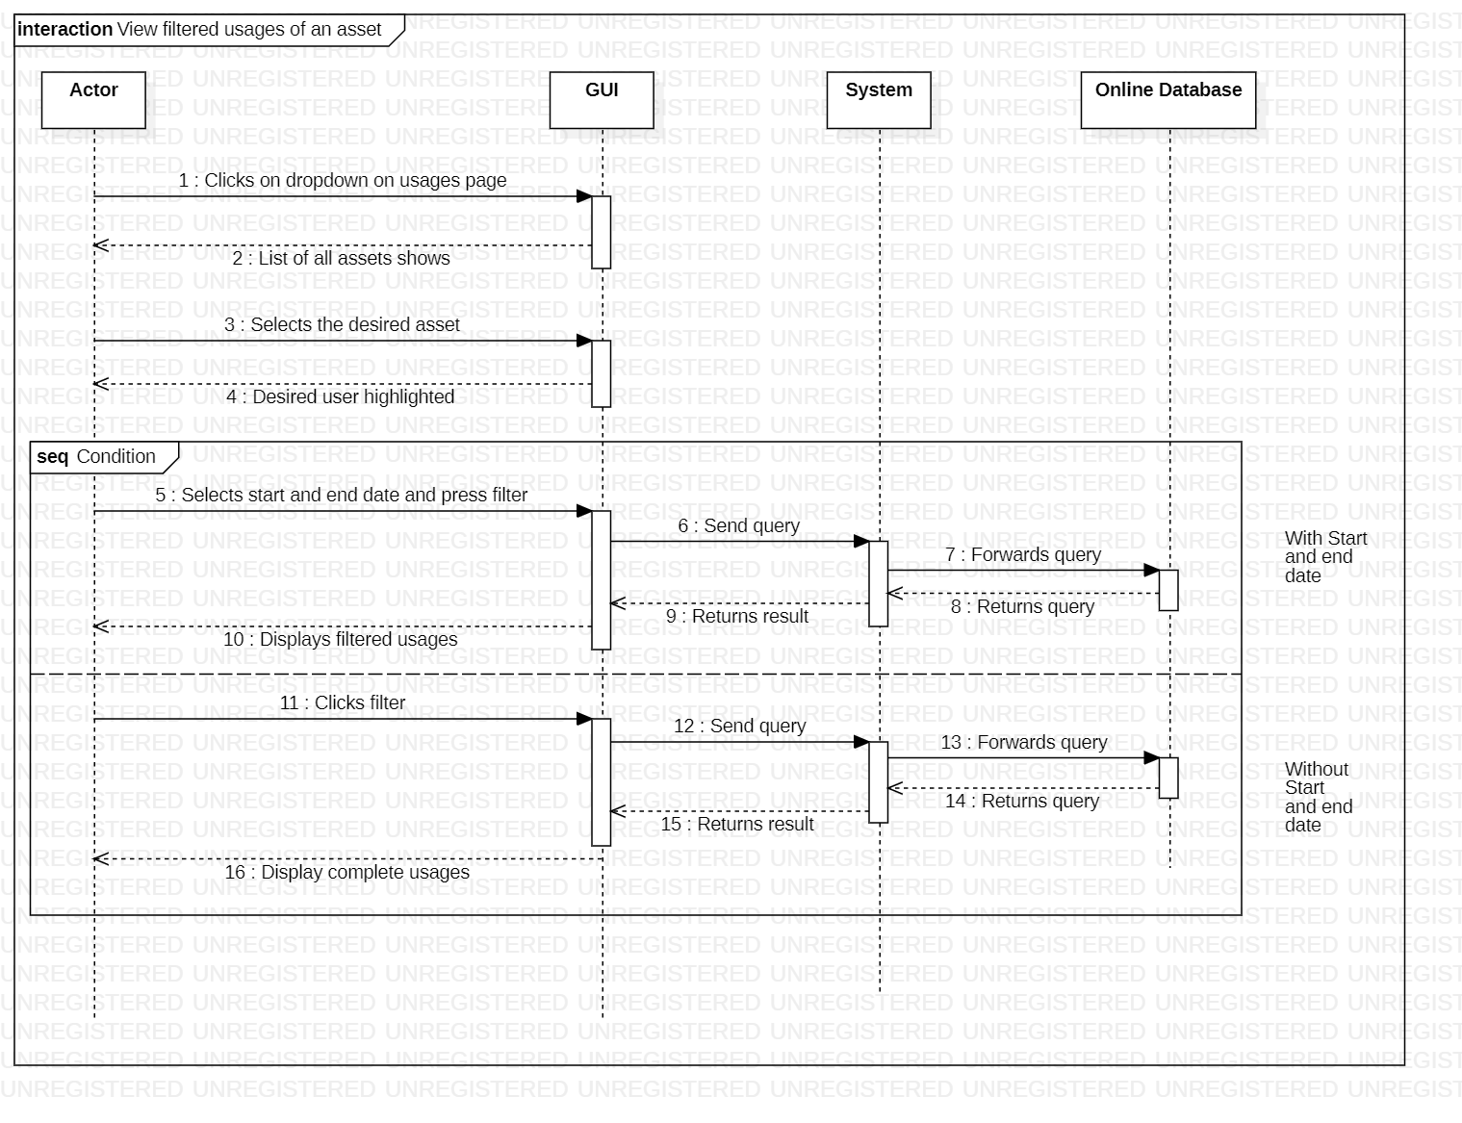

Figure 52: View Filtered Usages of an Asset

This is the sequence diagram of view filtered usages of an asset.

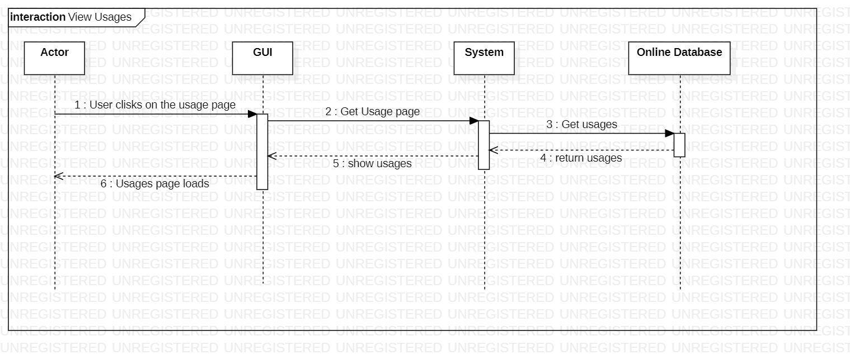

Figure 53: View Usages

This is the sequence diagram of view usages.

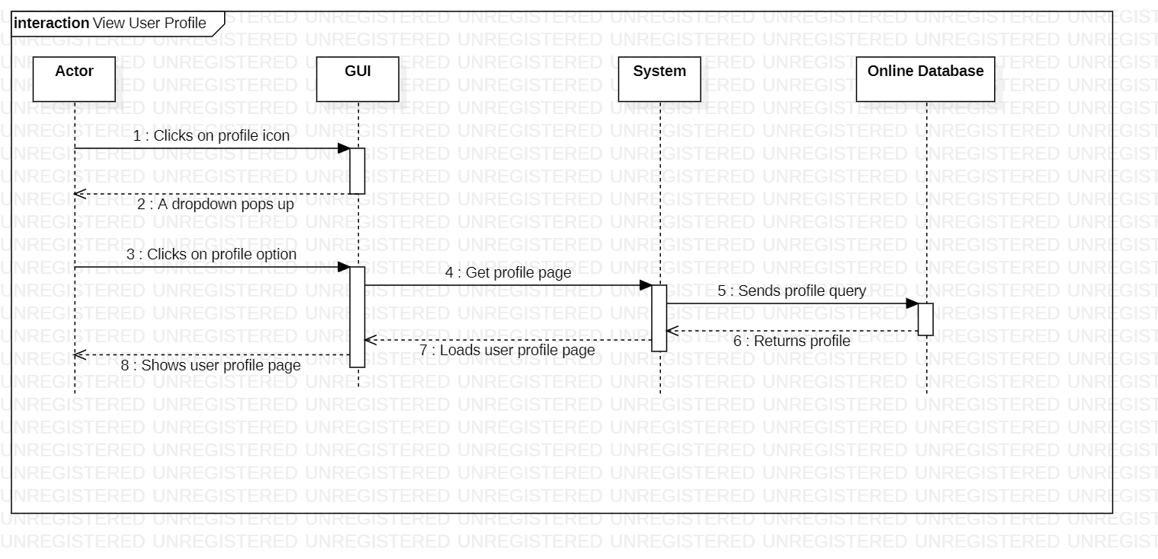

Figure 54: View User Profile

This is the sequence diagram of view user profile.

# 

# Policies and Tactics

## Libraries and Database

All data in our application will be coming from the IoT devices attached to the vehicles. Data will be collected from these devices through an automated mechanism designed by our team.

## Coding guidelines and conventions

For the user interface the eight golden rules of interface design would be utilized as a standard. During the programming phase of the project, rules and standards set in spring boot, python and react would be followed. Moreover, for naming convention of variables camel case will be used.

## Testing the software

SOAP UI testing tool will be used for API testing throughout the project. The accuracy of the different predictive models would be tested with testing data after training the model on the training data provided to choose the best model.

## Maintaining the software

More advanced versions of the software would be introduced after the completion of this project. To increase the scope of the product predictive maintenance of several other assets will be introduced.

## Protocol

HTTP protocol will be used to exchange information among client side and server side on the application. To share information between different microservices Kafka will be used. Moreover, data will be in JSON format while transmitting over a network link.

## Accessing the application

The web application would be hosted on cloud accessible with a URL link. The application would be accessible on the internet via any computer having minimum requirements. Users must authenticate while entering the application.

# References

1. Reutskaja, E., Lindner, A., Nagel, R. et al. “Choice overload reduces neural signatures of choice set value in dorsal striatum and anterior cingulate cortex.” *Nature Human Behavior,* vol 2, no. 925–935, Oct, 2018. [Online serial]. Available:

<https://doi.org/10.1038/s41562-018-0440-2> [Accessed Sept. 30, 2021]